SMASH BURGERS WITH MUSTARD SAUCE  COOK TIME: 20 mins  SOURCE: Unknown  #beef #American #pan-fry | 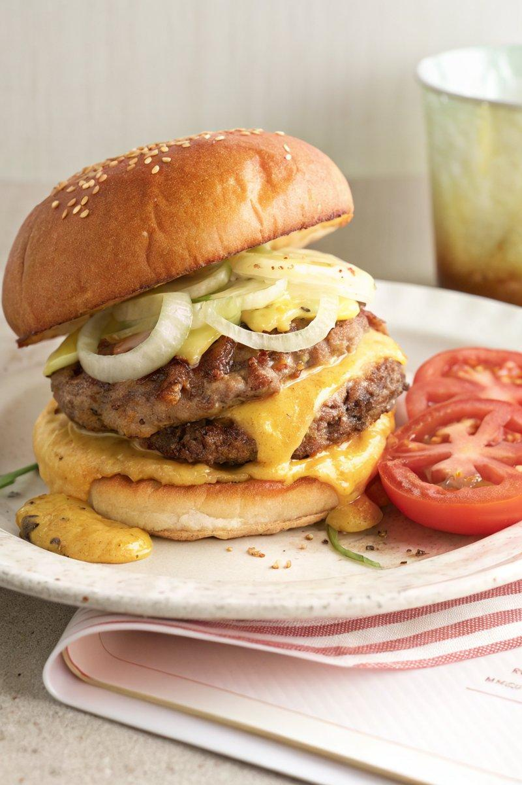

INGREDIENTS  - {'group': 'Main', 'item': '500g ground beef (70-80% lean)'}  - {'group': 'Main', 'item': '1 large sweet onion, sliced into thick rounds'}  - {'group': 'Main', 'item': '4 slices Gouda cheese'}  - {'group': 'Main', 'item': '4 buns'}  - {'group': 'Main', 'item': '1-2 heirloom tomatoes, sliced'}  - {'group': 'Main', 'item': '2 dill pickles, sliced lengthwise'}  - {'group': 'Main', 'item': '1 head iceberg lettuce, thinly sliced'}  - {'group': 'Sauce', 'item': '150ml mayonnaise'}  - {'group': 'Sauce', 'item': '2 tbsp whole-grain mustard'}  - {'group': 'Sauce', 'item': '1 bunch chives, finely sliced'}  - {'group': 'Sauce', 'item': '1 clove garlic, grated'}  - {'group': 'Sauce', 'item': '1 tbsp hot sauce (optional)'}  - {'group': 'Seasoning', 'item': 'Kosher salt and freshly cracked black pepper, to taste'} | PREP  Slice the sweet onion into thick rounds. Prepare the mustard sauce by mixing mayonnaise, whole-grain mustard, chives, garlic, and hot sauce in a bowl. Cover and refrigerate until needed. Slice the tomatoes and pickles, and thinly slice the iceberg lettuce.  COOK  Heat a 25-cm skillet over medium-high heat with a little oil. Add the onion slices, season with salt, and cook until lightly charred. Set aside. Form the ground beef into four 110g balls. Heat a large cast-iron skillet over medium-high heat. Place the beef balls in the skillet, smash them into patties about 1.25cm thick, and season with salt. Sear for ~3 mins until a crust forms, then flip and cook for another 3-4 mins. Top each patty with two slices of cheese, add a splash of water to the pan, cover, and steam until the cheese melts.  PLATING  Generously butter the cut sides of the buns and toast them on a griddle until golden. Spread mustard sauce on the bottom buns, layer with tomatoes, pickles, lettuce, and a beef patty. Top with charred onions and another dollop of sauce. Cap with the top bun and serve immediately.

NOTES:
For a spicier kick, increase the amount of hot sauce in the mustard sauce. Serve with fries or coleslaw for a complete meal.

