CRISPY FRIED BRUSSELS SPROUTS WITH SWEET AND SPICY SAUCE  COOK TIME: 20 mins  SOURCE: Unknown  #vegetable #asian #deep-fry | 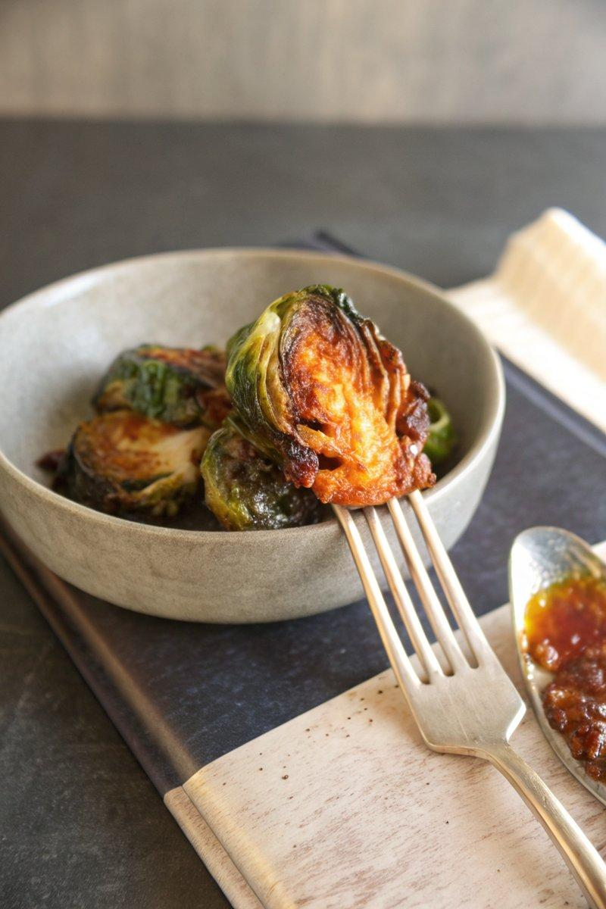

INGREDIENTS  - {'group': 'Main', 'item': '450g brussels sprouts, halved or quartered'}  - {'group': 'Sauce', 'item': '125g granulated sugar'}  - {'group': 'Sauce', 'item': '125ml white distilled vinegar'}  - {'group': 'Sauce', 'item': '125ml soy sauce'}  - {'group': 'Sauce', 'item': '60ml fish sauce'}  - {'group': 'Sauce', 'item': '60ml fresh orange juice'}  - {'group': 'Sauce', 'item': '5cm piece fresh ginger, peeled and grated'}  - {'group': 'Sauce', 'item': '2 fresh Thai or serrano chilies, thinly sliced'}  - {'group': 'Thickener', 'item': '1 tbsp cornstarch'}  - {'group': 'Thickener', 'item': '25ml filtered water'}  - {'group': 'Sauce', 'item': '4 cloves garlic, finely chopped'}  - {'group': 'Frying', 'item': 'High-heat oil for frying'}  - {'group': 'Seasoning', 'item': 'Kosher salt, to taste'}  - {'group': 'Seasoning', 'item': 'Fresh lemon juice, to taste'} | PREP  Halve or quarter the Brussels sprouts depending on their size. Peel and grate the ginger, and thinly slice the chilies. Finely chop the garlic.  COOK  In a medium saucepan, combine sugar, vinegar, soy sauce, fish sauce, orange juice, ginger, and chilies. Bring to a boil over medium-high heat, stirring occasionally, and let it boil for 3 to 5 minutes. In a small bowl, mix cornstarch with water to form a slurry. Whisk the slurry into the boiling sauce and cook for another 1 to 2 minutes until thickened. Remove from heat, stir in garlic, and let it steep for 5 minutes. Strain the sauce and discard solids. Heat oil in a large deep skillet to 180°C (350°F (175°C)). Fry Brussels sprouts in batches for about 7 minutes until browned and crispy. Remove with a slotted spoon and drain.  PLATING  Toss the fried Brussels sprouts with the sauce in a serving bowl. Season with salt and a squeeze of lemon juice before serving.

NOTES:
Ensure the oil is at the correct temperature to achieve the perfect crispiness. Adjust the amount of chilies to control the spice level.

