CHARRED KALE WITH GARLIC AND PARMESAN  COOK TIME: 15 mins  SOURCE: Unknown  #vegetarian #Mediterranean #pan-fry | 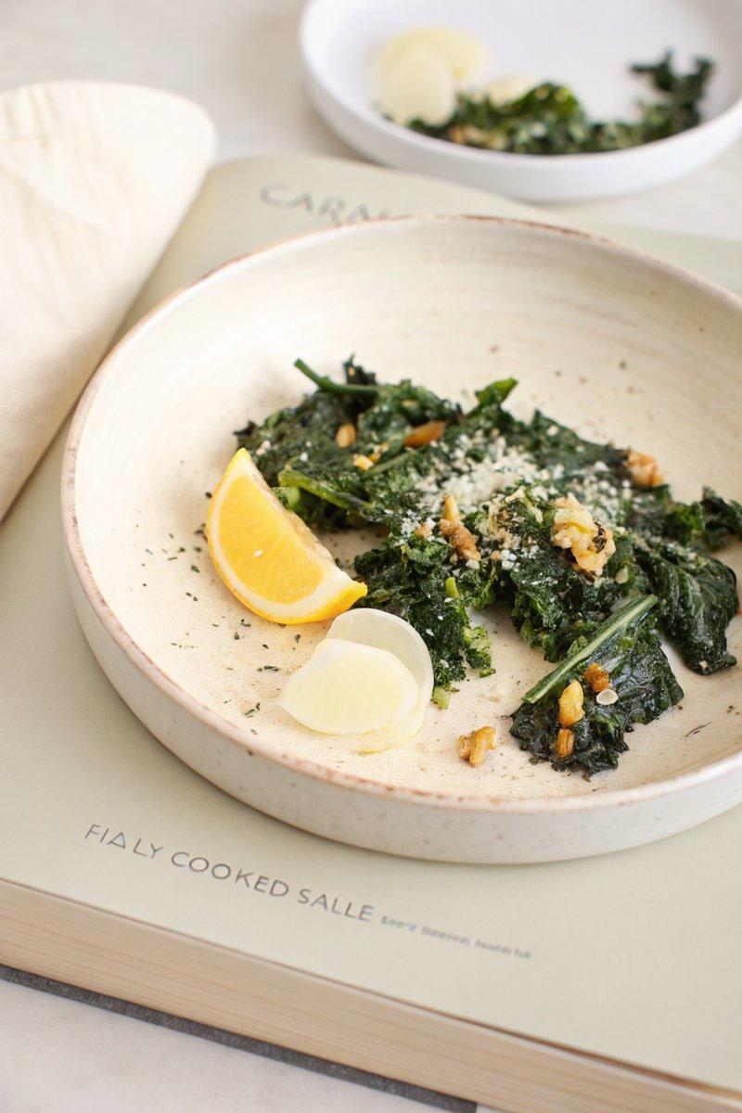

INGREDIENTS  - {'group': 'Main', 'item': '1 bunch kale, stems removed and leaves torn'}  - {'group': 'Main', 'item': '2 cloves garlic, peeled'}  - {'group': 'Main', 'item': '2 tbsp olive oil, divided'}  - {'group': 'Seasoning', 'item': 'Salt and freshly cracked black pepper, to taste'}  - {'group': 'Garnish', 'item': 'Zest of 1 lemon'}  - {'group': 'Garnish', 'item': 'Juice of 1 lemon'}  - {'group': 'Garnish', 'item': 'Parmigiano-Reggiano cheese, shaved'} | PREP  Prepare the kale by removing the stems and tearing the leaves into large pieces. Peel the garlic cloves. Zest and juice the lemon, keeping them separate.  COOK  Heat 1 tbsp of olive oil in a large skillet over medium-high heat. Once hot, add a portion of the kale in a single layer. Allow it to sear undisturbed for 1-2 mins until it begins to char. Toss and continue cooking for another 3-4 mins until the kale is wilted and charred on both sides. Remove to a bowl and repeat with remaining kale, adding more oil as needed. While the kale is still hot, grate the garlic over it, add lemon juice, and season with salt and pepper. Toss to combine and adjust seasoning if necessary.  PLATING  Transfer the charred kale to serving plates. Garnish with lemon zest and freshly shaved Parmigiano-Reggiano. Drizzle with additional olive oil if desired before serving.

NOTES:
For best results, ensure the skillet is very hot before adding the kale to achieve a good char. Adjust the amount of lemon juice and Parmesan to taste.

