ROASTED BROCCOLINI WITH TOASTED PEANUTS AND CHILI OIL  COOK TIME: 25 mins  SOURCE: Unknown  #vegetable #asian #roast | 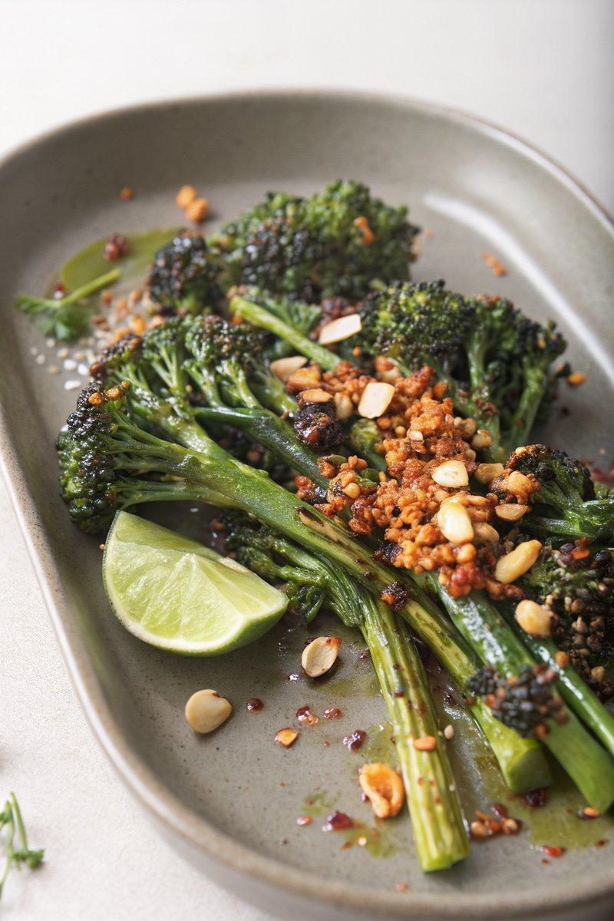

INGREDIENTS  - {'group': 'Main', 'item': '2 bunches of broccolini'}  - {'group': 'Main', 'item': '2½ tbsp (40 ml) extra-virgin olive oil'}  - {'group': 'Main', 'item': 'Kosher salt and freshly cracked black pepper, to taste'}  - {'group': 'Main', 'item': '½ cup (75g) raw peanuts'}  - {'group': 'Sauce', 'item': '2 tbsp (30 ml) chili oil'}  - {'group': 'Garnish', 'item': 'Zest and juice of 1 lime'}  - {'group': 'Garnish', 'item': 'Thinly sliced fresh serrano chiles (optional)'}  - {'group': 'Garnish', 'item': 'Flaky sea salt'} | PREP  Preheat the oven to 190°C (375°F (190°C)). Line a baking sheet with parchment paper. Zest and juice the lime, and thinly slice the serrano chiles if using.  COOK  Spread the peanuts on the prepared baking sheet and toast in the oven for 8 minutes until deeply golden. Let them cool, then crush into medium-coarse crumbs. Increase the oven temperature to 200°C (400°F (200°C)). In a bowl, toss the broccolini with olive oil, salt, and pepper. Arrange on the baking sheet and roast for 15 minutes until al dente and lightly charred.  PLATING  Transfer the roasted broccolini to a serving plate. Drizzle with chili oil and lime juice. Top with lime zest, crushed peanuts, and serrano chiles if using. Sprinkle with flaky sea salt before serving.

NOTES:
For a milder dish, omit the serrano chiles. This dish pairs well with grilled meats or tofu.

