GRILLED CORN ESQUITES WITH SPICY MAYO  COOK TIME: 10 mins  SOURCE: Unknown  #corn #Mexican #grill | 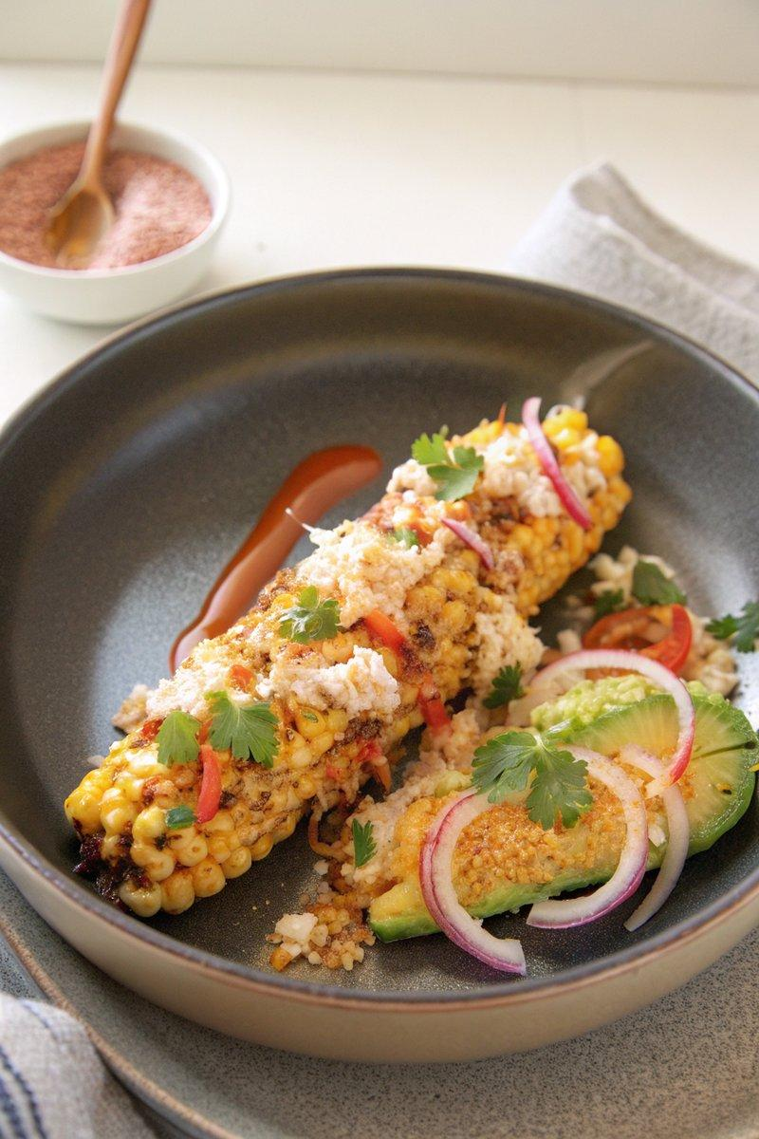

INGREDIENTS  - {'group': 'Main', 'item': '4 medium ears of corn, shucked'}  - {'group': 'Sauce', 'item': '3 tbsp spicy mayo'}  - {'group': 'Seasoning', 'item': 'Kosher salt, to taste'}  - {'group': 'Seasoning', 'item': '2 tsp smoked paprika'}  - {'group': 'Seasoning', 'item': 'Juice of 1 lime'}  - {'group': 'Garnish', 'item': 'Hot sauce, to serve'}  - {'group': 'Garnish', 'item': 'Pickled red onions, to serve'}  - {'group': 'Garnish', 'item': 'Diced avocado, to serve'}  - {'group': 'Garnish', 'item': 'Thinly sliced fresh serrano chiles, to serve'}  - {'group': 'Garnish', 'item': 'Freshly grated aged Manchego cheese, to serve'}  - {'group': 'Garnish', 'item': 'Cilantro leaves, for garnish'} | PREP  Shuck the corn and prepare the spicy mayo. Juice the lime and set aside the juice. Slice the serrano chiles and dice the avocado.  COOK  Preheat a grill. Grill the corn on all sides until lightly charred and the kernels are tender, about 10 minutes. Remove the kernels from the cobs using a knife and place them in a large bowl.  PLATING  Mix the grilled corn with spicy mayo, lime juice, smoked paprika, and salt in the bowl. Spoon the mixture into serving bowls and top with hot sauce, pickled red onions, diced avocado, serrano chiles, and Manchego cheese. Garnish with cilantro leaves before serving.

NOTES:
For extra flavour, adjust the amount of hot sauce and lime juice to your preference. This dish is best served immediately to maintain the crispness of the corn.

