CLASSIC COBB SALAD WITH CHEVRE  COOK TIME: 0 mins  SOURCE: Unknown  #salad #american #no-cook | 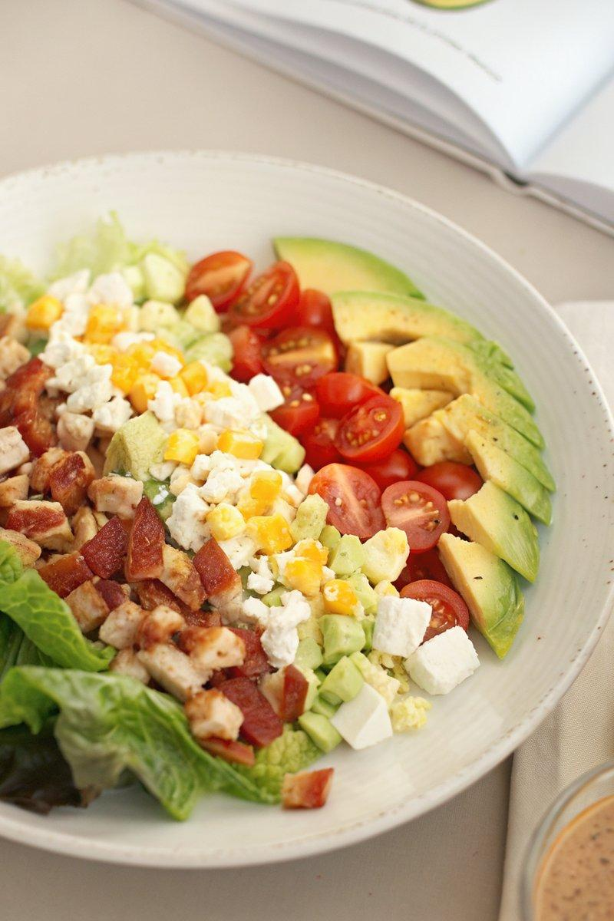

INGREDIENTS  - {'group': 'Main', 'item': '100g chevre, crumbled'}  - {'group': 'Dressing', 'item': '60ml vinaigrette dressing'} | PREP  Wash and dry the mixed lettuce leaves thoroughly. Crumble the chevre into small pieces.  COOK  This is a no-cook recipe.  PLATING  Arrange the lettuce leaves on a large serving platter. Scatter the crumbled chevre over the top. Drizzle with the vinaigrette dressing just before serving.

NOTES:
For a more robust flavour, consider adding sliced avocado or cherry tomatoes.

