ICEBERG WEDGE SALAD WITH RANCH AND PROSCIUTTO  COOK TIME: 15 mins  SOURCE: Unknown  #salad #american #no-cook | 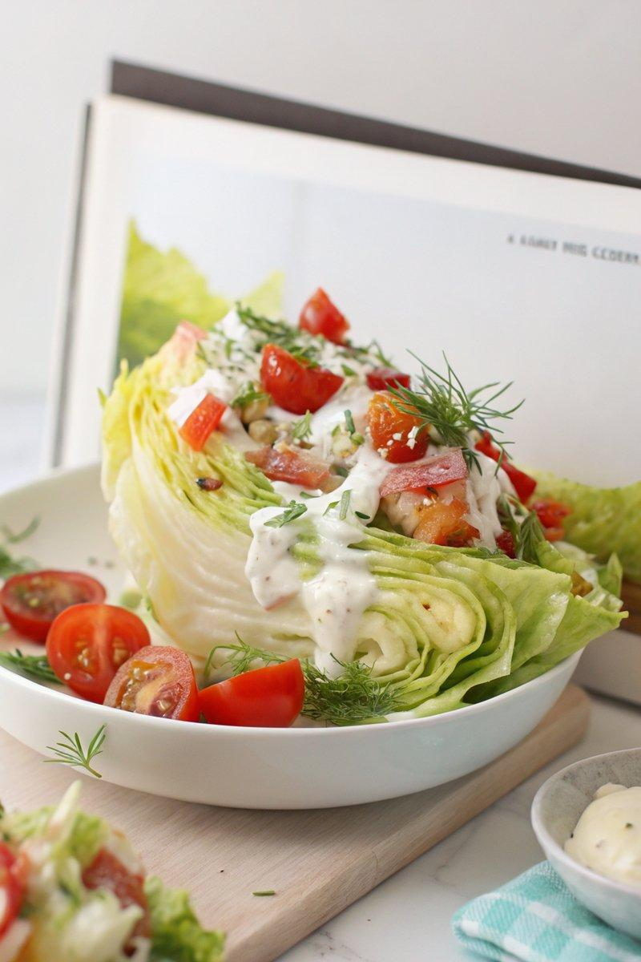

INGREDIENTS  - {'group': 'Main', 'item': '1 head iceberg lettuce'}  - {'group': 'Dressing', 'item': '240ml ranch dressing'}  - {'group': 'Toppings', 'item': '100g chèvre'}  - {'group': 'Toppings', 'item': '1 dill pickle, finely diced'}  - {'group': 'Toppings', 'item': '1 bunch chives, chopped'}  - {'group': 'Garnish', 'item': 'Fresh dill'}  - {'group': 'Seasoning', 'item': 'Freshly cracked black pepper'}  - {'group': 'Toppings', 'item': '200g cherry tomatoes'}  - {'group': 'Toppings', 'item': '100g prosciutto'} | PREP  Discard the outer leaves of the iceberg lettuce and cut the head into quarters, keeping a piece of the stem attached to each quarter to hold them together. Finely dice the dill pickle and chop the chives.  COOK  Heat a pan over medium heat and add the cherry tomatoes. Cook until they begin to blister and soften, then remove from the pan and set aside. In the same pan, lay the prosciutto slices in a single layer and cook until crispy, about 3-4 minutes per side. Remove and crumble once cooled.  PLATING  Place each lettuce quarter upright on a serving plate. Generously drizzle with ranch dressing. Top with blistered tomatoes, crumbled prosciutto, chèvre, diced dill pickle, and chopped chives. Garnish with fresh dill and a sprinkle of freshly cracked black pepper before serving.

NOTES:
For a vegetarian version, omit the prosciutto. This salad is best served immediately to maintain the crispness of the lettuce.

