CLASSIC CHICKEN NOODLE SOUP  COOK TIME: 1 hr 10 mins  SOURCE: Unknown  #chicken #American #simmer | 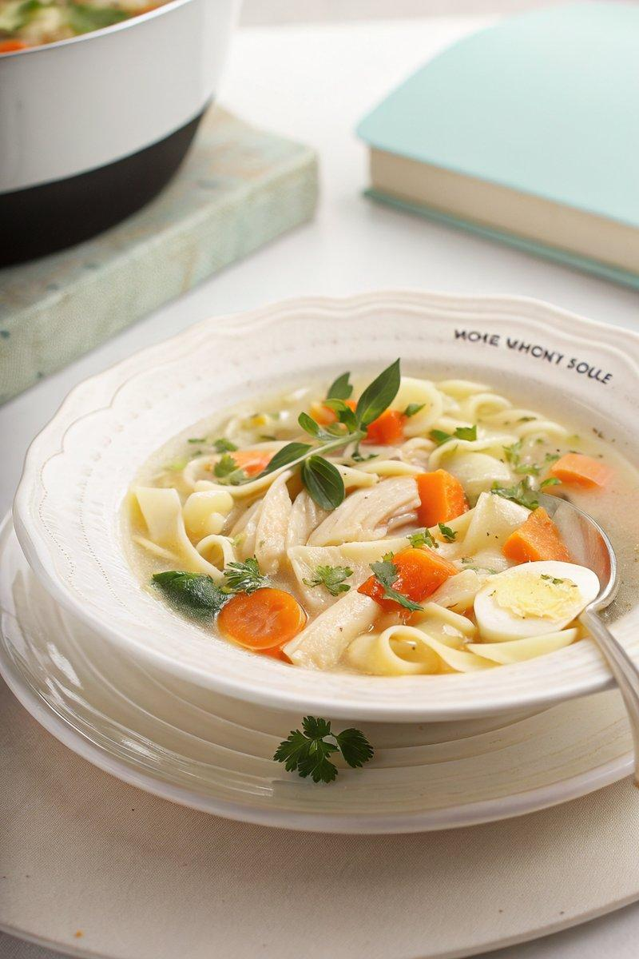

INGREDIENTS  - {'group': 'Main', 'item': '1 whole chicken'}  - {'group': 'Main', 'item': '2 carrots, sliced'}  - {'group': 'Main', 'item': '2 onions, quartered'}  - {'group': 'Main', 'item': '3.8L chicken stock'}  - {'group': 'Main', 'item': '300g egg noodles'}  - {'group': 'Seasoning', 'item': '2 bay leaves'}  - {'group': 'Seasoning', 'item': '3 thyme stems'}  - {'group': 'Seasoning', 'item': '2 sage leaves'}  - {'group': 'Seasoning', 'item': 'Salt and pepper to taste'}  - {'group': 'Garnish', 'item': 'Fresh herbs, torn or chopped'} | PREP  Prepare the vegetables by slicing the carrots and quartering the onions. Gather the thyme, sage, and bay leaves.  COOK  In a large stockpot, place the carrots, onions, and bay leaves. Lay the whole chicken on top and pour in 1.9L of chicken stock. Bring to a boil over high heat, then reduce to a gentle simmer. Cover and cook for 1 hour, or until the chicken is tender. Remove the chicken and herbs from the pot. Once cool enough to handle, debone the chicken and shred the meat. Return the shredded chicken to the pot. In a separate pot, bring the remaining 1.9L of chicken stock to a boil. Add the egg noodles and cook according to package instructions. Combine the cooked noodles and broth with the chicken mixture. Season generously with salt and pepper.  PLATING  Ladle the soup into bowls and garnish with fresh torn or chopped herbs before serving.

NOTES:
For the best flavour, use homemade chicken stock. Store-bought stock may result in a less flavourful soup.

