BEEF PHO WITH CHUCK ROAST AND MARROW  COOK TIME: 20 mins  SOURCE: Unknown  #beef #asian #soup | 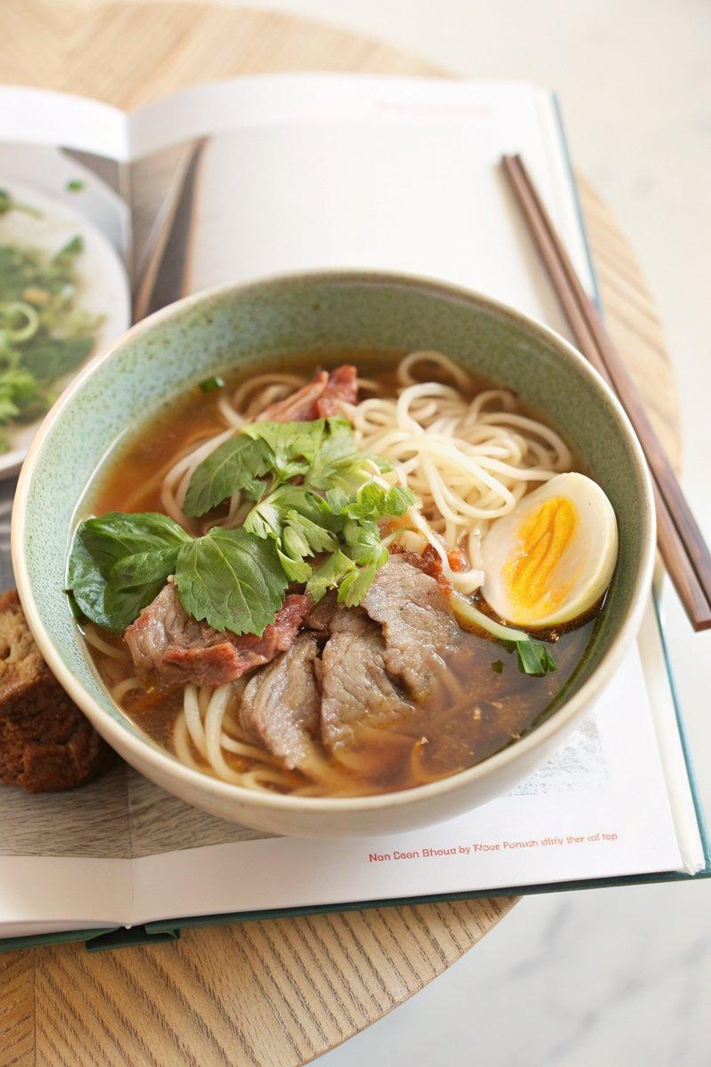

INGREDIENTS  - {'group': 'Main', 'item': '450g chuck roast, cooked and chilled'}  - {'group': 'Main', 'item': 'marrow from pho broth'}  - {'group': 'Main', 'item': '225g rice noodles, uncooked'}  - {'group': 'Garnish', 'item': '1 large sweet onion, thinly sliced'}  - {'group': 'Garnish', 'item': 'handful of Thai basil leaves'}  - {'group': 'Garnish', 'item': 'handful of cilantro'}  - {'group': 'Garnish', 'item': 'handful of mint leaves (optional)'}  - {'group': 'Garnish', 'item': '2 limes, halved'}  - {'group': 'For Serving', 'item': 'chili sauce'}  - {'group': 'For Serving', 'item': 'hoisin sauce'} | PREP  Thinly slice the chilled chuck roast. Slice the sweet onion and prepare the herbs by picking the leaves from the stems. Halve the limes.  COOK  Bring the pho broth to a boil. In a separate pot, cook the rice noodles according to package instructions, then rinse under warm water.  PLATING  Divide the cooked noodles among four bowls. Add slices of raw flank steak, cooked chuck roast, and marrow. Pour the boiling broth over the contents of each bowl. Top with sliced onions, Thai basil, cilantro, mint leaves, and lime halves. Serve with chili sauce and hoisin sauce on the side.

NOTES:
If Thai basil is unavailable, regular basil can be used as a substitute.

