CHICKEN TORTILLA SOUP  COOK TIME: 1 hr 20 mins  SOURCE: Unknown  #chicken #Mexican #soup | 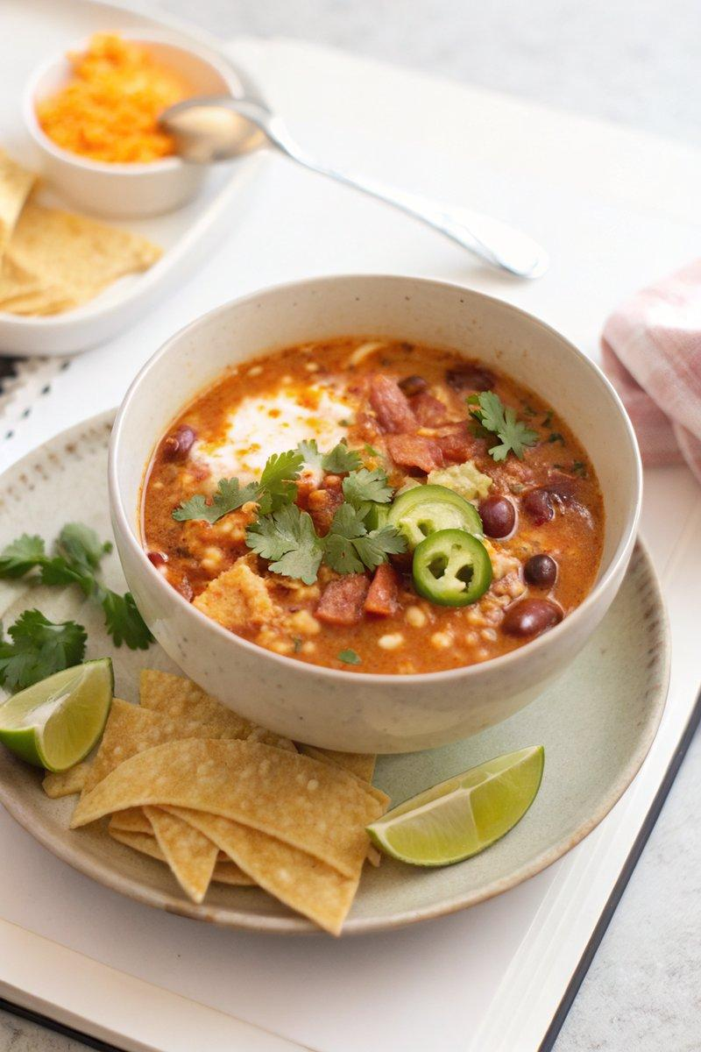

INGREDIENTS  - {'group': 'Main', 'item': '4 slices smoky bacon, chopped'}  - {'group': 'Main', 'item': '1 tsp unsalted butter'}  - {'group': 'Main', 'item': '1 medium yellow onion, roughly chopped'}  - {'group': 'Main', 'item': '4 cloves garlic, minced'}  - {'group': 'Main', 'item': '2 jalapeños, seeded and thinly sliced'}  - {'group': 'Main', 'item': '1 tbsp smoked paprika'}  - {'group': 'Main', 'item': '1 tsp ground cumin'}  - {'group': 'Main', 'item': '400g can crushed tomatoes'}  - {'group': 'Main', 'item': '750ml chicken stock'}  - {'group': 'Main', 'item': '1 tbsp finely chopped oregano'}  - {'group': 'Main', 'item': '170g fresh corn kernels'}  - {'group': 'Main', 'item': '400g can black beans, drained'}  - {'group': 'Main', 'item': '3 roasted chicken breasts, shredded'}  - {'group': 'Seasoning', 'item': 'Kosher salt and freshly cracked black pepper, to taste'}  - {'group': 'Topping', 'item': 'Tortilla chips, crushed'}  - {'group': 'Topping', 'item': '1 avocado, diced'}  - {'group': 'Topping', 'item': '168g shredded cheddar cheese'}  - {'group': 'Topping', 'item': '240ml sour cream'}  - {'group': 'Topping', 'item': 'Lime halves or wedges'}  - {'group': 'Topping', 'item': 'Cilantro'} | PREP  Chop the bacon and onion, mince the garlic, and slice the jalapeños. Shred the roasted chicken breasts.  COOK  In a cold stockpot, add the chopped bacon and cook over medium heat until browned and crispy, about 5-10 mins. Remove bacon with a slotted spoon and set aside. Add butter to the pot, then sauté the onion until translucent, about 3 mins. Add garlic and jalapeños, cooking until fragrant, about 1 min. Stir in smoked paprika and cumin, cooking for 30 seconds. Add crushed tomatoes and chicken stock, bring to a boil, then reduce to a simmer for 45 mins. Stir in oregano, corn, black beans, chicken, and bacon. Season with salt and pepper, and cook until heated through.  PLATING  Serve the soup hot, garnished with crushed tortilla chips, diced avocado, shredded cheddar cheese, a dollop of sour cream, lime wedges, and cilantro.

NOTES:
For a spicier soup, leave the seeds in the jalapeños. Adjust seasoning to taste with additional salt and pepper if needed.

