SHOYU RAMEN WITH CHASHU AND SOFT-BOILED EGGS  COOK TIME: 35 mins  SOURCE: Unknown  #pork #asian #soup | 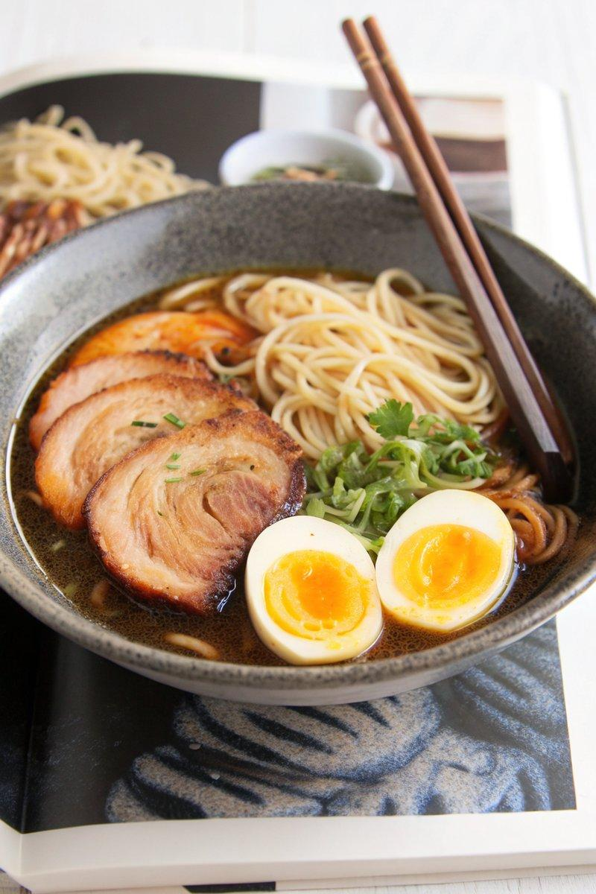

INGREDIENTS  - {'group': 'Main', 'item': '4 servings cooked straight ramen noodles'}  - {'group': 'Tare (Sauce)', 'item': '125ml shoyu'}  - {'group': 'Tare (Sauce)', 'item': '50ml mirin'}  - {'group': 'Tare (Sauce)', 'item': '5-7.5cm piece kombu'}  - {'group': 'Soup Base', 'item': '25g dried shiitake mushrooms'}  - {'group': 'Soup Base', 'item': '625ml pork or chicken stock'}  - {'group': 'Soup Base', 'item': '30ml neutral-tasting oil'}  - {'group': 'Soup Base', 'item': '10ml toasted sesame oil'}  - {'group': 'Soup Base', 'item': '5cm piece fresh ginger, peeled and minced'}  - {'group': 'Soup Base', 'item': '3 cloves garlic, minced'}  - {'group': 'Soup Base', 'item': '75ml sake'}  - {'group': 'Soup Base', 'item': '750ml dashi'}  - {'group': 'Soup Base', 'item': '12g kosher salt'}  - {'group': 'Toppings', 'item': '4-8 slices chashu'}  - {'group': 'Toppings', 'item': '4 soft-boiled eggs'}  - {'group': 'Toppings', 'item': '2 green onions, sliced'}  - {'group': 'Toppings', 'item': 'Nori, cut into 2.5 x 5cm pieces'}  - {'group': 'Toppings', 'item': 'Chili oil'} | PREP  Combine shoyu, mirin, and kombu in a saucepan. Heat until steaming, then steep for 10 mins. Remove kombu and refrigerate tare. Rehydrate shiitake mushrooms in boiling stock for 10-15 mins, then slice.  COOK  In a stockpot, heat neutral oil and sesame oil. Sauté ginger and garlic until fragrant, then add sake and reduce by 90%. Add mushroom stock, dashi, and salt. Simmer for 10 mins, then strain.  PLATING  In each bowl, add a few tablespoons of tare, followed by noodles. Pour in broth, then top with sliced mushrooms, chashu, eggs, green onions, nori, and chili oil. Adjust tare to taste.

NOTES:
For a vegetarian version, use vegetable stock and omit chashu. Adjust seasoning with additional soy sauce if needed.

