VEGETARIAN RENDANG MUSHROOMS  COOK TIME: 45 mins  SOURCE: Unknown  #vegetarian #asian #grill | 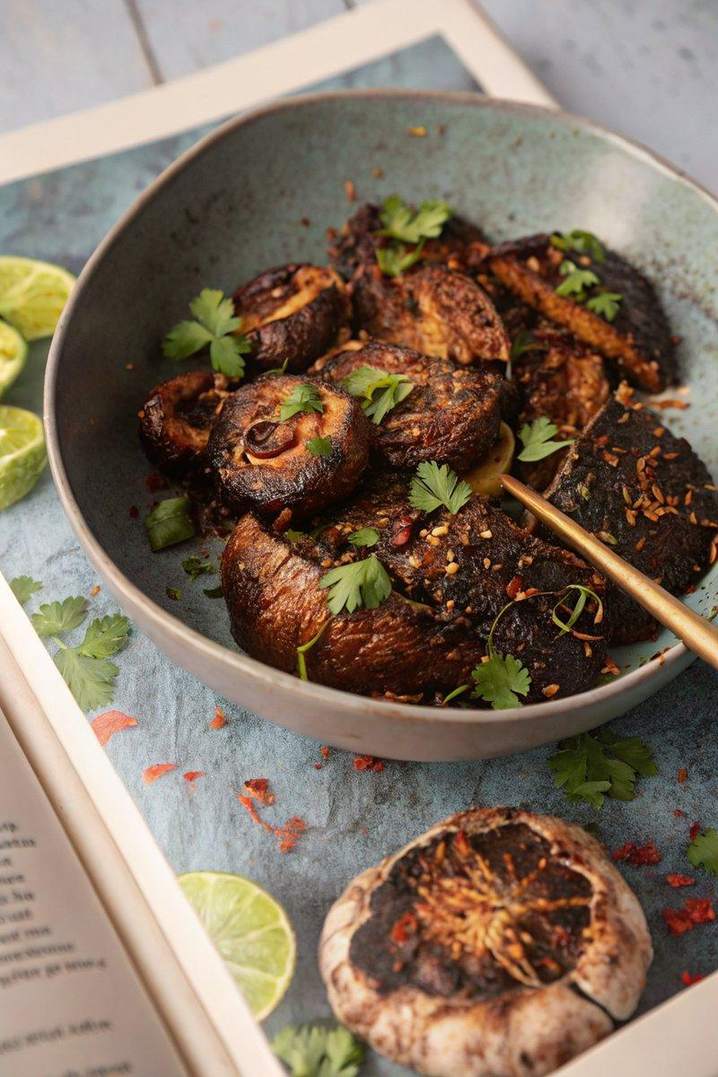

INGREDIENTS  - {'group': 'Main', 'item': '1kg portobello mushrooms'}  - {'group': 'Sauce', 'item': '250g salted butter'}  - {'group': 'Sauce', 'item': '2 tbsp vegetable oil'}  - {'group': 'Sauce', 'item': '200g rendang paste'}  - {'group': 'Sauce', 'item': '1 lemongrass stalk, chopped'}  - {'group': 'Sauce', 'item': '5 kaffir lime leaves'}  - {'group': 'Sauce', 'item': '50g palm sugar'}  - {'group': 'Sauce', 'item': '3 tbsp rendang spice mix'}  - {'group': 'Sauce', 'item': '1 tbsp chilli oil'}  - {'group': 'Sauce', 'item': '2 tbsp lemon juice'}  - {'group': 'Sauce', 'item': 'zest of 1 lemon'}  - {'group': 'Garnish', 'item': '2 tbsp coriander leaves'}  - {'group': 'Garnish', 'item': '2 extra kaffir lime leaves, finely shredded'} | PREP  Allow the butter to soften at room temperature. Chop the lemongrass and shred the extra kaffir lime leaves. Peel the mushrooms and trim their stems.  COOK  Heat the vegetable oil in a heavy-based saucepan over medium heat. Add the rendang paste, lemongrass, and kaffir lime leaves, cooking for about 40 minutes until the oil separates from the paste. Stir occasionally to prevent sticking, adding a splash of water if necessary. Once aromatic, incorporate the palm sugar and rendang spice mix, cooking until fragrant. Remove from heat and let cool. In a large bowl, combine the softened butter with the cooled rendang paste, chilli oil, lemon juice, and zest. Shape into logs using cling film and freeze until firm. Preheat a barbecue or chargrill pan. Brush the mushrooms with oil and grill cap-side down. Place a 1cm slice of the rendang butter on each mushroom, allowing it to melt before flipping. Grill for an additional 5 minutes.  PLATING  Arrange the grilled mushrooms on a serving platter. Garnish with shredded kaffir lime leaves and coriander leaves before serving.

NOTES:
Ensure the rendang paste is cooked thoroughly to develop its full flavour. Adjust the chilli oil to taste for desired heat level.

