TRADITIONAL MEXICAN MOLE SAUCE  COOK TIME: 3 hrs  SOURCE: Unknown  #sauce #Mexican #simmer | 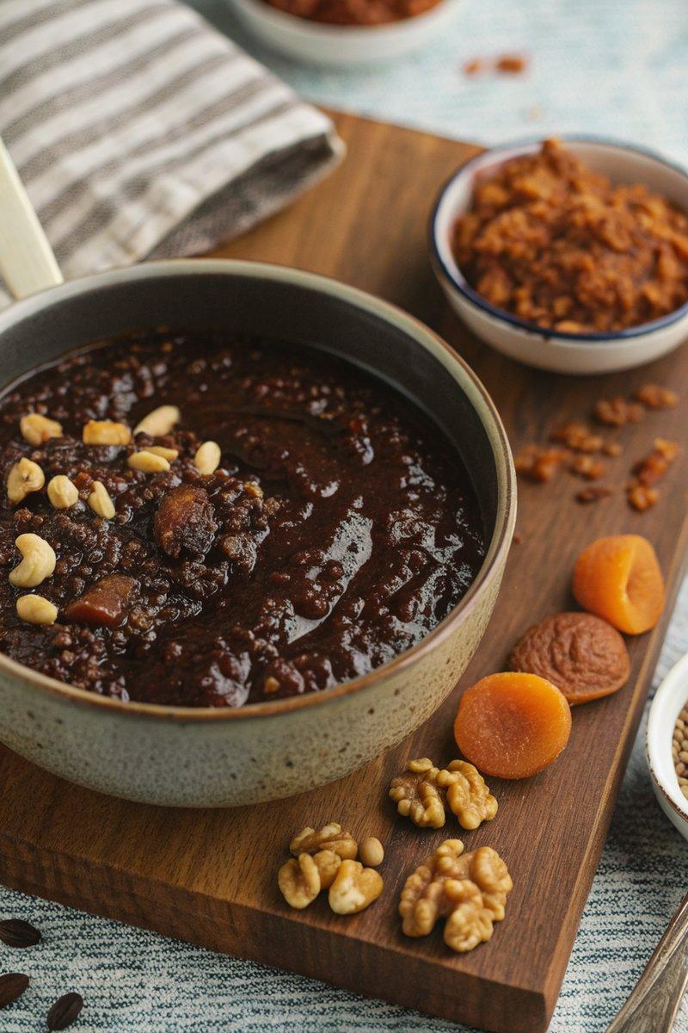

INGREDIENTS  - {'group': 'Main', 'item': '100g dried mulato chillies'}  - {'group': 'Main', 'item': '25g dried pasilla chillies'}  - {'group': 'Main', 'item': '10g raw cashew nuts'}  - {'group': 'Main', 'item': '10g blanched almonds'}  - {'group': 'Main', 'item': '10g shelled hazelnuts'}  - {'group': 'Main', 'item': '10g shelled walnuts'}  - {'group': 'Main', 'item': '10g raw peanuts'}  - {'group': 'Main', 'item': '10g sesame seeds'}  - {'group': 'Main', 'item': '10g pumpkin seeds'}  - {'group': 'Main', 'item': '1 onion, roughly chopped'}  - {'group': 'Main', 'item': '10g dried apricots, roughly chopped'}  - {'group': 'Seasoning', 'item': 'a pinch of ground cinnamon'}  - {'group': 'Seasoning', 'item': 'a pinch of ground allspice'}  - {'group': 'Main', 'item': '200 ml groundnut oil'}  - {'group': 'Main', 'item': '500 ml chicken stock'}  - {'group': 'Main', 'item': '20g soft dark brown sugar'}  - {'group': 'Main', 'item': '10g caster sugar'}  - {'group': 'Main', 'item': '40g dark chocolate (80% cocoa solids), broken up'} | PREP  Toast the dried mulato and pasilla chillies, then soak them in hot water. Toast the cashew nuts, almonds, hazelnuts, walnuts, peanuts, sesame seeds, and pumpkin seeds separately until lightly browned. Roughly chop the onion and dried apricots.  COOK  In a food processor, blend the toasted nuts and seeds until they release their oils and form a liquid paste, about 20 minutes. Add the soaked chillies, onion, apricots, cinnamon, and allspice to the processor, blending until smooth. Heat the groundnut oil in a heavy-based pan over low heat, then add the blended mixture. Cook for 30 minutes, stirring constantly. Pour in the chicken stock and simmer on low heat for 2 hours, stirring every 20 minutes. Add the brown sugar, caster sugar, and dark chocolate, and simmer for an additional 30 minutes.  PLATING  Serve the mole sauce warm over your choice of protein, such as chicken or pork, with rice or tortillas on the side.

NOTES:
This mole sauce can be stored in an airtight container in the refrigerator for up to a month.

