CONFIT CHERRY TOMATOES  COOK TIME: 2 hrs  SOURCE: Unknown  #tomatoes #Mediterranean #bake | 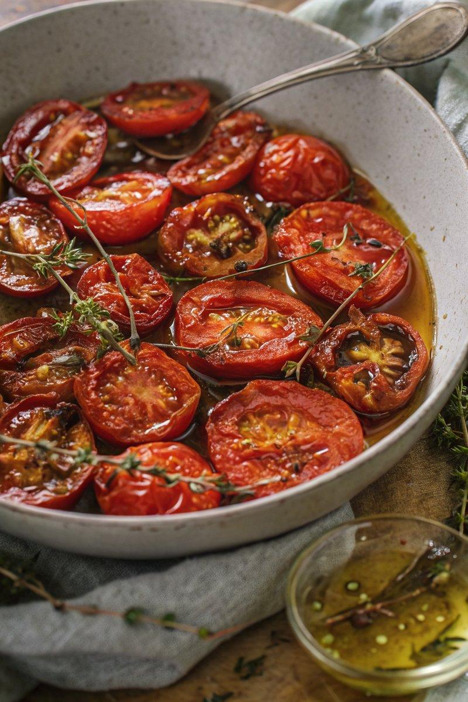

INGREDIENTS  - {'group': 'Main', 'item': '500g cherry tomatoes, halved'}  - {'group': 'Main', 'item': 'Sunflower oil, enough to cover'}  - {'group': 'Seasoning', 'item': '1 tbsp salt'}  - {'group': 'Seasoning', 'item': '1 tbsp sugar'}  - {'group': 'Seasoning', 'item': '1 tbsp dried oregano'}  - {'group': 'Seasoning', 'item': '6 sprigs fresh thyme'} | PREP  Preheat the oven to 90°C (194°F (90°C)). Halve the cherry tomatoes and arrange them cut side up in a snug roasting tin.  COOK  Pour sunflower oil over the tomatoes until just covered. Sprinkle evenly with salt, sugar, oregano, and thyme. Bake for about 2 hours until the tomatoes are shrivelled but not burnt.  PLATING  Store the confit tomatoes in an airtight container under oil for up to one week. Serve as a side or topping.

NOTES:
Ensure the tomatoes are fully submerged in oil to preserve them longer. Adjust seasoning to taste if desired.

