COLLARD GREENS, CHICKPEA AND LENTIL SOUP  COOK TIME: 30 mins  SOURCE: Unknown  #vegetarian #asian #soup | 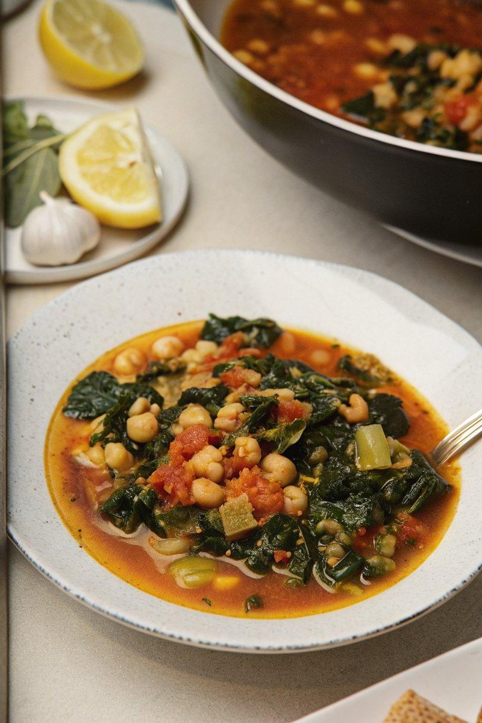

INGREDIENTS  - {'group': 'Main', 'item': '100g red lentils'}  - {'group': 'Main', 'item': '2 tbsp extra-virgin olive oil'}  - {'group': 'Main', 'item': '1 medium onion, diced'}  - {'group': 'Main', 'item': '4 garlic cloves, sliced'}  - {'group': 'Main', 'item': '2.5 cm piece fresh ginger, grated'}  - {'group': 'Main', 'item': '5 cm piece cinnamon stick'}  - {'group': 'Seasoning', 'item': '1 tsp ground black pepper'}  - {'group': 'Seasoning', 'item': '0.5 to 1 tsp red chilli powder'}  - {'group': 'Seasoning', 'item': '0.5 tsp ground turmeric'}  - {'group': 'Main', 'item': '2 tbsp tomato paste'}  - {'group': 'Main', 'item': '1 medium tomato, diced'}  - {'group': 'Main', 'item': '200g collard greens, chopped'}  - {'group': 'Main', 'item': '445g can chickpeas, drained and rinsed'}  - {'group': 'Main', 'item': '960 ml vegetable stock'}  - {'group': 'Main', 'item': '1 tbsp tamarind paste'}  - {'group': 'Garnish', 'item': '2 tbsp chopped flat-leaf parsley'}  - {'group': 'Garnish', 'item': '2 tbsp chopped cilantro'} | PREP  Rinse the red lentils under running water and soak them in 120 ml of water for 30 minutes. Dice the onion, slice the garlic, and grate the ginger. Chop the collard greens, removing the midribs.  COOK  Heat olive oil in a large saucepan over medium-high heat. Sauté the diced onion until translucent, about 4-5 minutes. Add garlic and ginger, cooking until fragrant, about 1 minute. Stir in cinnamon stick, black pepper, red chilli powder, and turmeric, sautéing for 30-45 seconds. Mix in tomato paste and cook until it begins to brown, about 2-3 minutes. Add diced tomato and collard greens, cooking until the greens are bright green, about 1-2 minutes. Drain the lentils and add them to the pot along with chickpeas and vegetable stock. Bring to a boil, then reduce to a simmer and cook until lentils are tender, about 25-30 minutes. Stir in tamarind paste and season with salt to taste.  PLATING  Before serving, stir in chopped parsley and cilantro. Serve hot with toasted buttered bread or naan.

NOTES:
If pressed for time, you can skip soaking the lentils, but adjust cooking time as needed. The soup's tangy flavour comes from tamarind and tomatoes, balancing the bitterness of collard greens.

