ROASTED FRUIT WITH COFFEE MISO TAHINI  COOK TIME: 30 mins  SOURCE: Unknown  #fruit #fusion #roast | 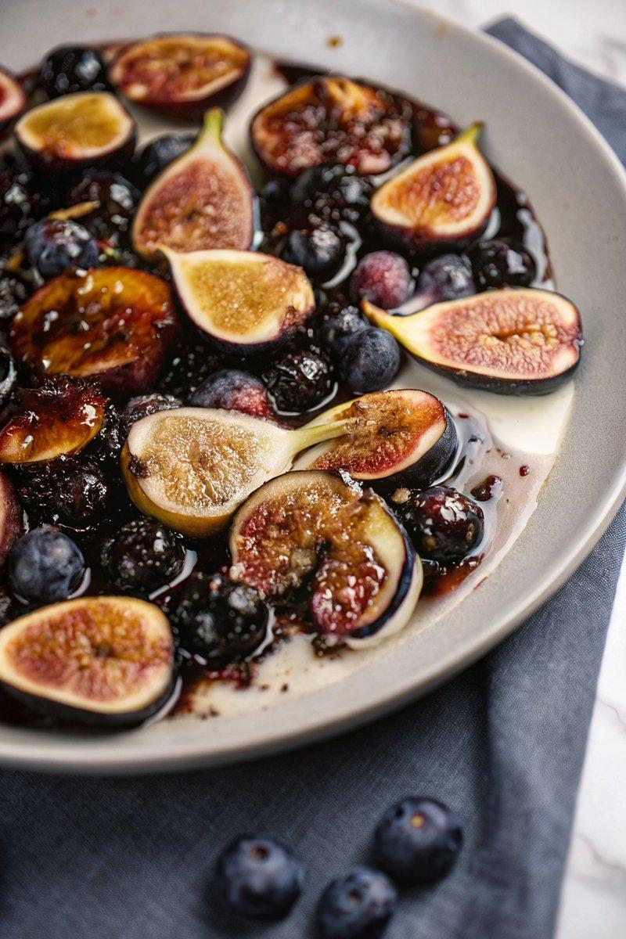

INGREDIENTS  - {'group': 'Main', 'item': '340g blueberries, fresh or frozen'}  - {'group': 'Main', 'item': '340g fresh figs, sliced in half'}  - {'group': 'Main', 'item': '2 tbsp fresh lime juice'}  - {'group': 'Main', 'item': '2 tbsp maple syrup'}  - {'group': 'Main', 'item': '2 tbsp unsalted butter'}  - {'group': 'Main', 'item': '1/4 tsp ground black pepper'}  - {'group': 'Main', 'item': '1/4 tsp fine sea salt'}  - {'group': 'Sauce', 'item': '2 tbsp shiro or sweet white miso'}  - {'group': 'Sauce', 'item': '1/4 cup maple syrup or honey'}  - {'group': 'Sauce', 'item': '1/4 cup tahini'}  - {'group': 'Sauce', 'item': '1/4 tsp instant espresso or coffee powder'}  - {'group': 'Sauce', 'item': 'Fine sea salt to taste'} | PREP  Preheat the oven to 190°C (375°F (190°C)). Grease an 8 by 10-inch (25cm (10-inch)) baking dish with butter and place it on a parchment-lined baking sheet. In a bowl, combine blueberries, figs, lime juice, maple syrup, black pepper, and salt. Toss to coat.  COOK  Transfer the fruit mixture to the prepared baking dish, spreading it evenly. Dot with butter and roast for 25-30 minutes until the figs caramelize and the fruits release their juices.  PLATING  Whisk together miso, maple syrup, tahini, water, and espresso powder until smooth. Adjust seasoning with salt. Drizzle the sauce over the warm roasted fruit and serve the rest on the side. Optionally, serve over ice cream or Greek yogurt.

NOTES:
This dish pairs well with vanilla or cardamom ice cream. For an extra kick, consider adding crystallized ginger to the sauce.

