HAZELNUT CARAMEL FLAN  COOK TIME: 1 hr  SOURCE: Unknown  #hazelnut #Indian #bake | 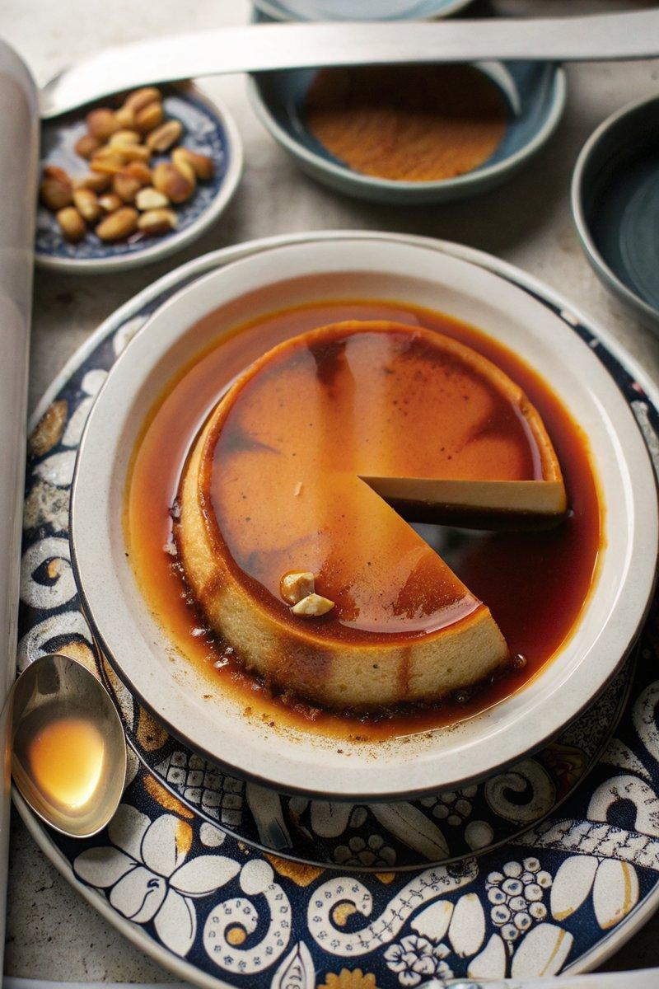

INGREDIENTS  - {'group': 'Caramel', 'item': '1/4 tsp cream of tartar'}  - {'group': 'Caramel', 'item': '150g sugar'}  - {'group': 'Flan', 'item': '480ml whole milk or hazelnut-infused milk'}  - {'group': 'Flan', 'item': '400g sweetened condensed milk'}  - {'group': 'Flan', 'item': '1 tsp hazelnut extract or 2 tbsp hazelnut creamer'}  - {'group': 'Flan', 'item': '1/4 tsp fine sea salt'}  - {'group': 'Flan', 'item': '4 large eggs'} | PREP  If making hazelnut-infused milk, toast hazelnuts and steep them in milk a day in advance. Preheat the oven to 163°C (325°F (165°C)).  COOK  In a small saucepan, combine 60ml of water with cream of tartar. Add sugar to the center and cook over medium-high heat without stirring until it caramelizes to a dark brown, about 6-8 mins. Pour the caramel into a 20cm round cake pan, swirling to coat the bottom evenly. In a large bowl, gently mix the whole milk, sweetened condensed milk, hazelnut extract, sea salt, and eggs until combined, avoiding air bubbles. Pour the mixture over the caramel in the cake pan. Place the pan in a larger baking dish and fill the dish with hot water halfway up the sides of the cake pan. Bake for 1 hour until the flan is set but still slightly jiggly in the center.  PLATING  Allow the flan to cool to room temperature, then refrigerate for at least 4 hours or overnight. To serve, run a knife around the edges of the flan and invert onto a serving plate.

NOTES:
For a smoother texture, avoid whisking the eggs vigorously. The flan can be made a day ahead and stored in the refrigerator.

