CHOCOLATE MISO BREAD PUDDING  COOK TIME: 1 hr  SOURCE: Unknown  #chocolate #fusion #baked | 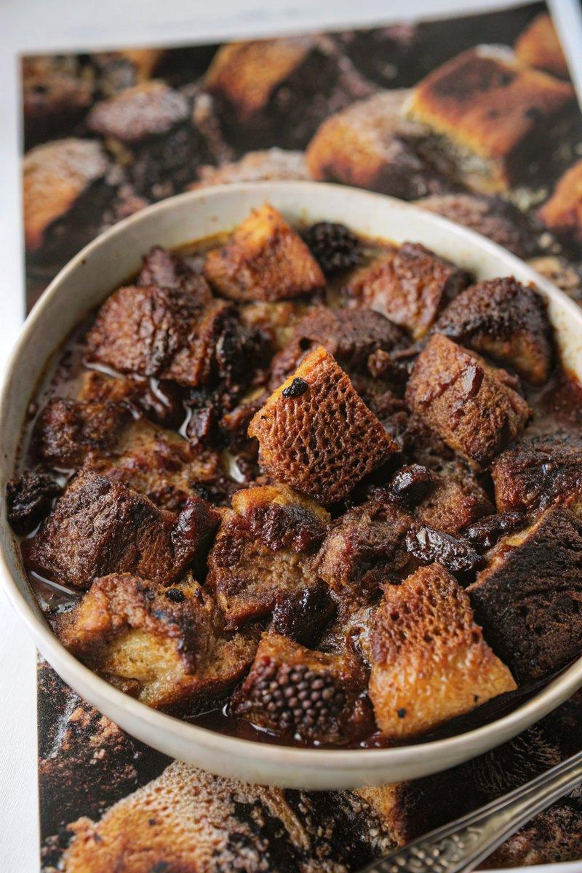

INGREDIENTS  - {'group': 'Main', 'item': '455g challah or brioche, cut into 2.5 cm cubes'}  - {'group': 'Main', 'item': '255g bittersweet chocolate (70% cacao), chopped'}  - {'group': 'Main', 'item': '85g dried tart cherries'}  - {'group': 'Main', 'item': '2 tbsp unsalted butter, cubed'}  - {'group': 'Custard', 'item': '360ml heavy cream'}  - {'group': 'Custard', 'item': '40g shiro or sweet white miso'}  - {'group': 'Custard', 'item': '360ml whole milk'}  - {'group': 'Custard', 'item': '150g sugar'}  - {'group': 'Custard', 'item': '3 large eggs plus 1 yolk, lightly whisked'}  - {'group': 'Custard', 'item': '1 tsp instant coffee or espresso'}  - {'group': 'Custard', 'item': '¼ tsp fine sea salt (optional)'} | PREP  If the bread is not stale, preheat the oven to 93°C (199°F (93°C)). Arrange the bread cubes on a wire rack over a baking sheet and dry in the oven for 45 mins to 1 hr, or leave them out overnight at room temperature.  COOK  Butter a 23x30.5x5cm (2x2-inch (5cm (2-inch))) baking pan and add the bread cubes. Sprinkle half of the chopped chocolate and the cherries over the bread, folding them in gently. Warm the cream in a saucepan over medium-high heat until it begins to bubble. Pour it over the remaining chocolate and instant coffee in a large bowl, whisking until smooth. In a separate bowl, mix 120ml of this chocolate mixture with the miso until smooth, then combine with the rest of the chocolate mixture. Whisk in the milk, sugar, eggs, yolk, and salt. Pour this custard over the bread cubes, cover with plastic wrap, and refrigerate for at least 1 hr or overnight.  PLATING  Preheat the oven to 163°C (325°F (165°C)). Remove the plastic wrap from the baking pan and dot the surface with butter cubes. Bake for about 1 hr until the top is crisp and the pudding is firm. Serve warm or at room temperature.

NOTES:
For an extra crunch, use challah or brioche with poppy or sesame seeds. This dessert pairs well with vanilla or green cardamom ice cream.

