HONEY GARLIC BUTTER BAKED SALMON  COOK TIME: 15 mins  SOURCE: Unknown  #salmon #Mediterranean #baked | 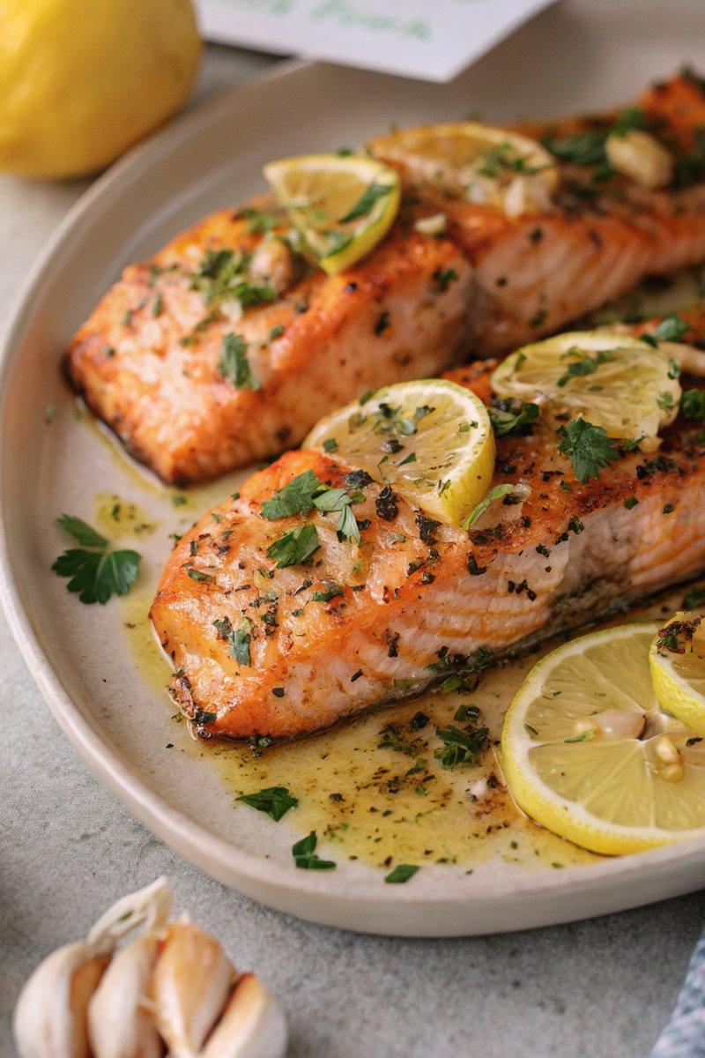

INGREDIENTS  - {'group': 'Main', 'item': '4 skin-on salmon fillets'}  - {'group': 'Sauce', 'item': '2 tbsp unsalted butter, melted'}  - {'group': 'Sauce', 'item': '2 garlic cloves, minced'}  - {'group': 'Sauce', 'item': '2 tbsp honey'}  - {'group': 'Seasoning', 'item': '1/2 tsp dried parsley or 2 tsp fresh flat-leaf parsley, chopped'}  - {'group': 'Seasoning', 'item': '1/4 tsp salt'}  - {'group': 'Seasoning', 'item': '1/4 tsp ground black pepper'}  - {'group': 'Seasoning', 'item': 'a pinch of paprika'}  - {'group': 'Garnish', 'item': '1 lemon, sliced into half-moons'} | PREP  Preheat the oven to 200°C (400°F (200°C)). Line a baking tray with foil or a silicon mat. Mince the garlic and slice the lemon into half-moons.  COOK  Place the salmon fillets skin-side down on the prepared baking tray. In a small bowl, combine the melted butter, minced garlic, honey, parsley, salt, pepper, and paprika. Pour this mixture over the salmon fillets, allowing it to pool around them. Arrange the lemon slices on and around the salmon. Bake in the oven for 8 minutes, then baste the salmon with the sauce from the tray. Continue baking for another 4-7 minutes until the salmon is tender and cooked through.  PLATING  Serve the salmon fillets hot, garnished with the baked lemon slices. Pair with your favourite steamed vegetables or rice.

NOTES:
Leftover salmon can be served cold in a salad or wrap. Cool, cover, and refrigerate before flaking for use.

