CAJUN COD WITH SMOKY POTATO WEDGES  COOK TIME: 30 mins  SOURCE: Unknown  #fish #American #bake | 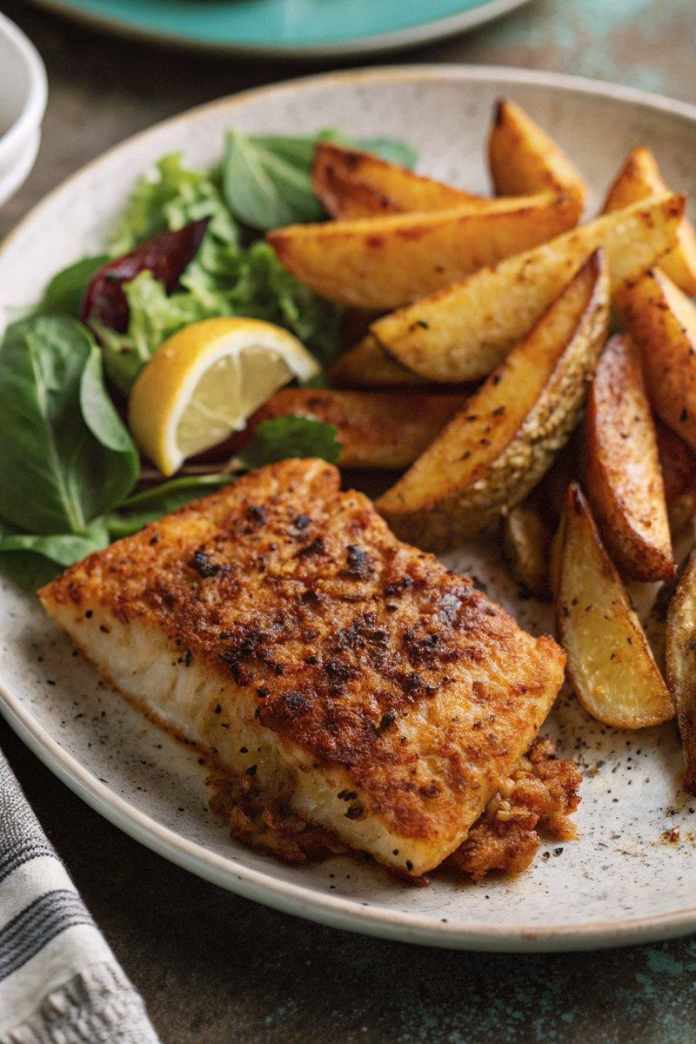

INGREDIENTS  - {'group': 'Main', 'item': '500g floury white potatoes, sliced into wedges'}  - {'group': 'Main', 'item': '4 cod fillets'}  - {'group': 'Seasoning', 'item': '1/2 tsp salt'}  - {'group': 'Seasoning', 'item': '1/2 tsp ground black pepper'}  - {'group': 'Seasoning', 'item': '1/2 tsp smoked paprika'}  - {'group': 'Seasoning', 'item': '1/4 tsp garlic powder'}  - {'group': 'Seasoning', 'item': '1/4 tsp chilli flakes'}  - {'group': 'Seasoning', 'item': '2 tbsp Cajun spice mix'}  - {'group': 'Main', 'item': '4 tbsp olive oil'} | PREP  Preheat the oven to 200°C (400°F (200°C)). Slice the potatoes into wedges, leaving the skin on.  COOK  Arrange the potato wedges on a baking tray. Sprinkle with salt, pepper, smoked paprika, garlic powder, and chilli flakes. Drizzle with 2 tbsp olive oil and toss to coat. Bake for 20 mins. Meanwhile, place the cod fillets on another tray. Rub with Cajun spice mix, salt, and pepper, then brush with remaining olive oil. After 20 mins, turn the potatoes and place the cod tray above them in the oven. Bake for an additional 10-12 mins until the cod is cooked through and the potatoes are golden.  PLATING  Serve the baked cod and potato wedges alongside a simple green salad.

NOTES:
You can substitute cod with other white fish like pollock, hake, or haddock. Salmon also works well.

