BACON-WRAPPED CHICKEN WITH BBQ SAUCE AND CHEESE  COOK TIME: 30 mins  SOURCE: Unknown  #chicken #British #baked | 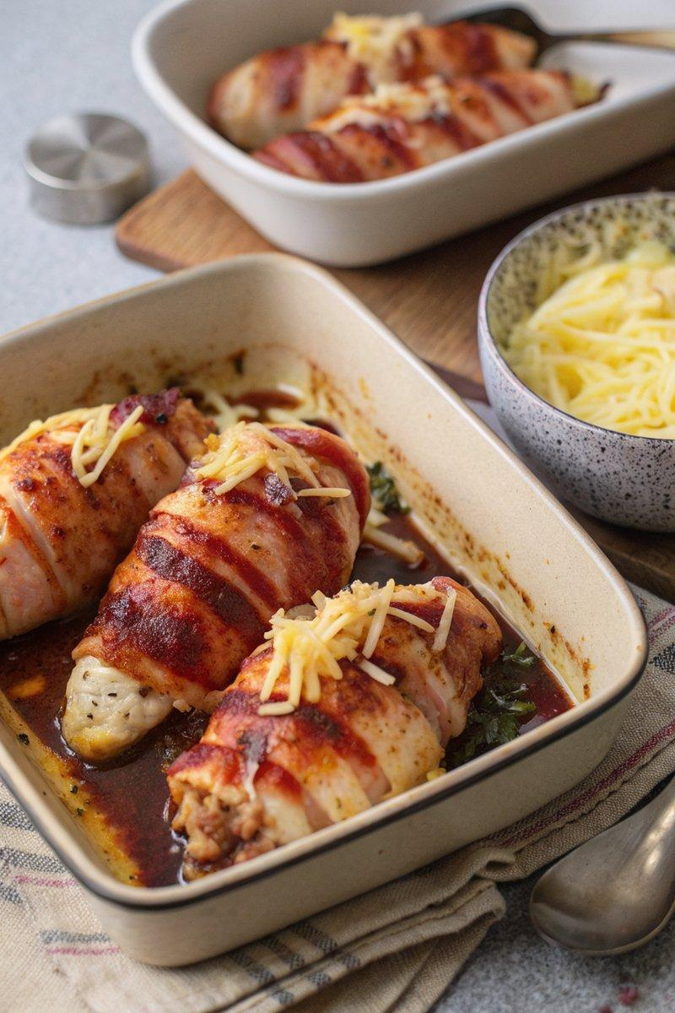

INGREDIENTS  - {'group': 'Main', 'item': '4 chicken breasts'}  - {'group': 'Main', 'item': '8 rashers streaky bacon'}  - {'group': 'Sauce', 'item': '240ml BBQ sauce'}  - {'group': 'Topping', 'item': '50g grated mature Cheddar'}  - {'group': 'Topping', 'item': '50g grated mozzarella'} | PREP  Preheat the oven to 200°C (400°F (200°C)). Wrap each chicken breast with two rashers of bacon.  COOK  Place the bacon-wrapped chicken in a shallow baking dish and bake for 25 minutes until the chicken is cooked through. Remove from the oven and cover the chicken with BBQ sauce. Sprinkle the grated Cheddar and mozzarella over the top. Return to the oven for an additional 5 minutes until the cheese is melted.  PLATING  Serve the chicken hot with mashed potato and your choice of vegetables, such as carrots, green beans, or broccoli.

NOTES:
For a twist on the BBQ sauce, consider adding honey, smoked paprika, or chilli powder for extra flavour.

