CREAMY CHICKEN WITH DIJON AND KALE  COOK TIME: 30 mins  SOURCE: Unknown  #chicken #French #pan-fry | 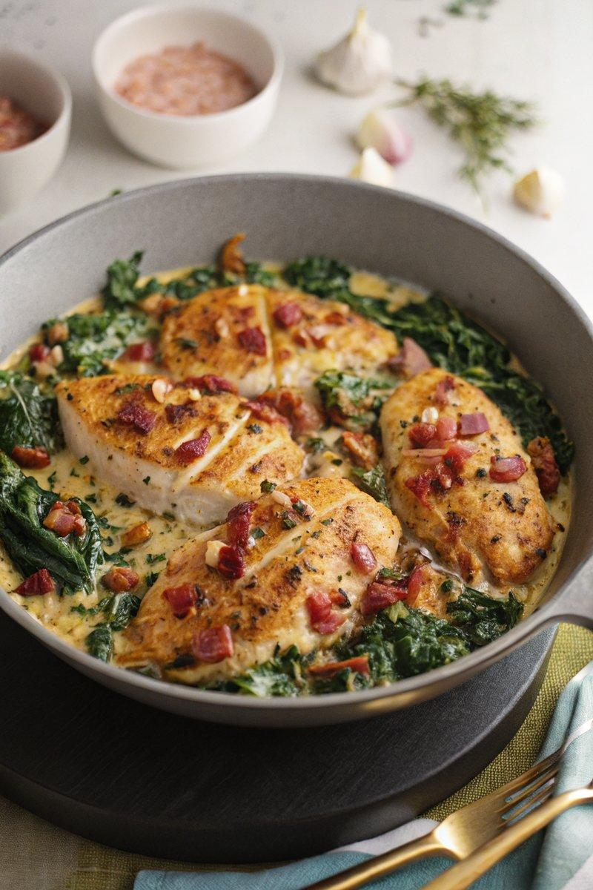

INGREDIENTS  - {'group': 'Main', 'item': '4 chicken breasts'}  - {'group': 'Seasoning', 'item': '1/2 tsp salt'}  - {'group': 'Seasoning', 'item': '1/4 tsp ground black pepper'}  - {'group': 'Seasoning', 'item': '1/4 tsp paprika'}  - {'group': 'Main', 'item': '1 tbsp sunflower oil'}  - {'group': 'Main', 'item': '4 rashers streaky bacon'}  - {'group': 'Main', 'item': '1 onion, peeled and chopped'}  - {'group': 'Main', 'item': '2 garlic cloves, peeled and minced'}  - {'group': 'Sauce', 'item': '2 tbsp Dijon mustard'}  - {'group': 'Sauce', 'item': '240 ml chicken stock'}  - {'group': 'Sauce', 'item': '120 ml double cream'}  - {'group': 'Main', 'item': '60g kale, finely shredded'}  - {'group': 'Garnish', 'item': '50g grated Parmesan'}  - {'group': 'Garnish', 'item': '10-12 pecans, roughly chopped'} | PREP  Flatten the chicken breasts to about 2cm thick using a rolling pin. Season them with salt, pepper, and paprika.  COOK  Heat sunflower oil in a large frying pan over medium heat. Cook the bacon until crispy, about 5 mins, then remove and chop. In the same pan, fry the chicken in the bacon fat until golden on one side, about 4-5 mins. Push the chicken to one side and add onion and garlic to the pan, cooking until the onion softens, about 3-4 mins. Stir in Dijon mustard, then pour in chicken stock and cream. Move the chicken back to the center, coat with sauce, and bring to a boil. Add kale and simmer for 10 mins until the chicken is cooked through and the sauce thickens.  PLATING  Turn off the heat and stir in Parmesan. Scatter chopped bacon and pecans over the top before serving.

NOTES:
For a variation, substitute kale with spinach, adding it only in the last 2 mins of cooking.

