MILD CHICKEN CURRY  COOK TIME: 25 mins  SOURCE: Unknown  #chicken #Asian #sauté | 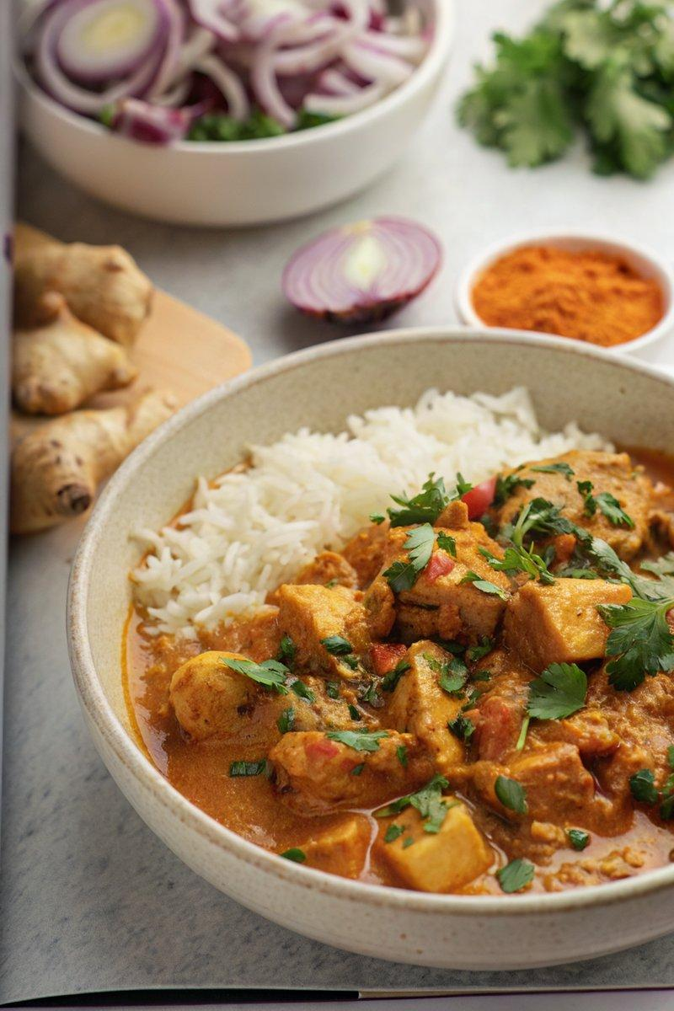

INGREDIENTS  - {'group': 'Main', 'item': '600g chicken breasts, chopped into bite-size chunks'}  - {'group': 'Main', 'item': '1 large onion, finely chopped'}  - {'group': 'Main', 'item': '2 garlic cloves, minced'}  - {'group': 'Main', 'item': '2 tsp minced ginger'}  - {'group': 'Sauce', 'item': '2 tbsp mild curry powder'}  - {'group': 'Sauce', 'item': '1 tbsp ground coriander'}  - {'group': 'Sauce', 'item': '1/2 tbsp ground cumin'}  - {'group': 'Sauce', 'item': '1 tsp paprika'}  - {'group': 'Sauce', 'item': '1/2 tsp ground cinnamon'}  - {'group': 'Sauce', 'item': '1/2 tsp salt'}  - {'group': 'Sauce', 'item': '1/2 tsp ground black pepper'}  - {'group': 'Sauce', 'item': '2 tbsp tomato purée'}  - {'group': 'Sauce', 'item': '400g can finely chopped tomatoes'}  - {'group': 'Sauce', 'item': '240ml chicken stock'}  - {'group': 'Sauce', 'item': '400ml can coconut milk'}  - {'group': 'Thickener', 'item': '1 tbsp cornflour mixed with 2 tbsp cold water (optional)'}  - {'group': 'Garnish', 'item': '60g baby spinach'}  - {'group': 'Garnish', 'item': 'fresh coriander'}  - {'group': 'Garnish', 'item': 'chilli flakes'} | PREP  Chop the chicken into bite-sized pieces. Finely chop the onion and mince the garlic and ginger.  COOK  Heat the sunflower oil in a large frying pan over medium-high heat. Add the chicken pieces and cook for about 5 minutes, turning occasionally, until browned. Add the onion and continue to cook for another 5 minutes until softened. Stir in the garlic, ginger, curry powder, coriander, cumin, paprika, cinnamon, salt, and pepper, cooking for an additional minute. Mix in the tomato purée, chopped tomatoes, chicken stock, and coconut milk. Bring the mixture to a gentle simmer and cook for 10 minutes, stirring occasionally, until the chicken is cooked through. If desired, thicken the curry by stirring in the cornflour slurry.  PLATING  Stir in the baby spinach until wilted, then remove from heat. Serve the curry over cooked rice, garnished with fresh coriander and chilli flakes.

NOTES:
This curry can be made ahead and stored in the refrigerator or freezer. Reheat gently on the stovetop, adding a splash of water if needed.

