TEX-MEX CHICKEN FAJITAS  COOK TIME: 20 mins  SOURCE: Unknown  #chicken #Mexican #pan-fry | 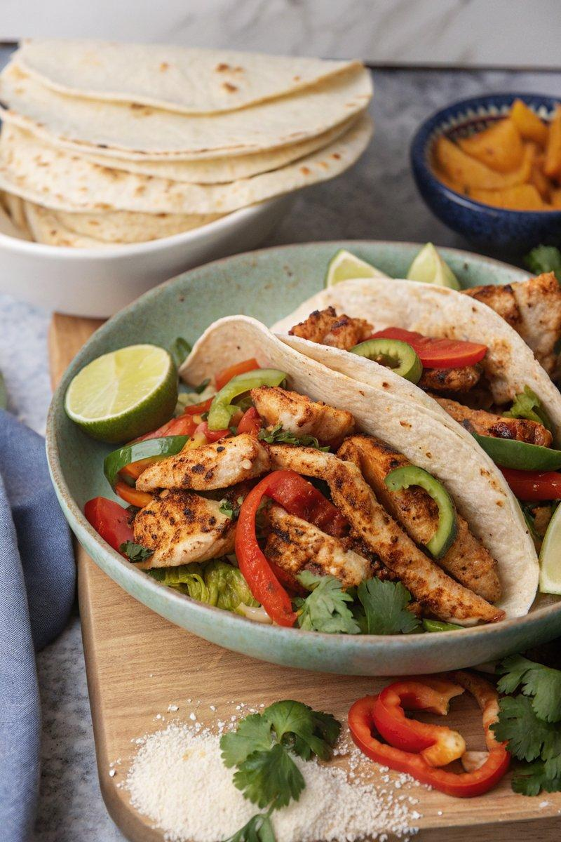

INGREDIENTS  - {'group': 'Main', 'item': '600g chicken breasts, sliced into strips'}  - {'group': 'Main', 'item': '3 tbsp sunflower oil'}  - {'group': 'Main', 'item': '2 tbsp fajita seasoning'}  - {'group': 'Main', 'item': '8 small flour tortillas'}  - {'group': 'Main', 'item': '1 red bell pepper, deseeded and sliced'}  - {'group': 'Main', 'item': '1 green bell pepper, deseeded and sliced'}  - {'group': 'Main', 'item': '1 yellow bell pepper, deseeded and sliced'}  - {'group': 'Main', 'item': '1 onion, peeled and thinly sliced'}  - {'group': 'Garnish', 'item': '1 avocado, sliced'}  - {'group': 'Garnish', 'item': 'A bunch of fresh coriander, roughly chopped'}  - {'group': 'For Serving', 'item': '120ml sour cream'}  - {'group': 'For Serving', 'item': '250g tomato salsa'}  - {'group': 'For Serving', 'item': '50g grated Cheddar'}  - {'group': 'For Serving', 'item': '1-2 jalapeños, sliced'}  - {'group': 'For Serving', 'item': '1-2 limes, sliced or cut into wedges'} | PREP  Slice the chicken breasts into strips. Deseed and slice the bell peppers. Peel and thinly slice the onion. Slice the avocado and brush with lemon or lime juice to prevent browning. Roughly chop the coriander.  COOK  Preheat the oven to its lowest setting and place a baking tray inside to warm. Coat the chicken strips with 2 tbsp of sunflower oil and fajita seasoning. Heat a cast-iron skillet over high heat. Toast the tortillas on the skillet until they have grill marks, about 1-2 mins per side, then keep warm. Add the remaining oil to the skillet and fry the peppers and onion until slightly charred and softened, about 8-10 mins. Transfer to the warm tray in the oven. Cook the chicken on the hot skillet until charred and cooked through, about 5-6 mins, turning once.  PLATING  Serve the cooked chicken with the charred peppers and onions in the warmed tortillas. Garnish with avocado slices and coriander. Offer sour cream, salsa, grated Cheddar, jalapeños, and lime wedges on the side for custom toppings.

NOTES:
No additional notes

