TERIYAKI BEEF NOODLES  COOK TIME: 20 mins  SOURCE: Unknown  #beef #Asian #stir-fry | 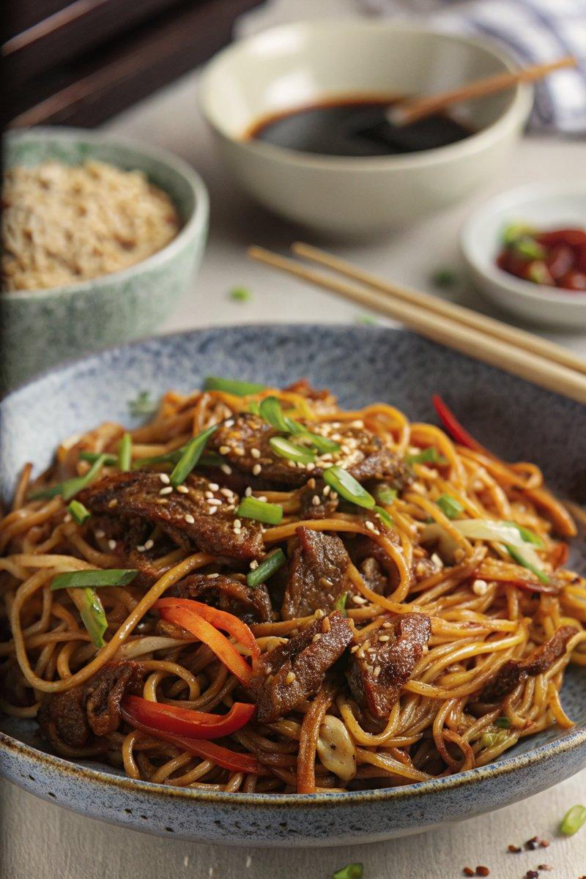

INGREDIENTS  - {'group': 'Marinade', 'item': '2 tbsp light soy sauce'}  - {'group': 'Marinade', 'item': '3 tbsp dark soy sauce'}  - {'group': 'Marinade', 'item': '1 tbsp sake or dry sherry'}  - {'group': 'Marinade', 'item': '3 tbsp mirin'}  - {'group': 'Marinade', 'item': '1 tsp sesame oil'}  - {'group': 'Marinade', 'item': '1 tbsp brown sugar'}  - {'group': 'Marinade', 'item': '2 tsp minced ginger'}  - {'group': 'Marinade', 'item': '3 garlic cloves, minced'}  - {'group': 'Marinade', 'item': '½ tsp white pepper'}  - {'group': 'Main', 'item': '500g Denver, sirloin, or skirt steak, cut into strips'}  - {'group': 'Main', 'item': '200g medium egg noodles'}  - {'group': 'Main', 'item': '1 tsp sesame oil'}  - {'group': 'Main', 'item': '1½ tbsp sunflower oil'}  - {'group': 'Main', 'item': '1 small onion, finely sliced'}  - {'group': 'Main', 'item': '1 red bell pepper, thinly sliced'}  - {'group': 'Main', 'item': '1 carrot, cut into matchsticks'}  - {'group': 'Main', 'item': '5 spring onions, sliced into thin strips'}  - {'group': 'Garnish', 'item': '¼ tsp chilli flakes'}  - {'group': 'Garnish', 'item': '1 tbsp sesame seeds'} | PREP  Combine all marinade ingredients in a bowl. Add beef strips to a separate bowl with one-third of the marinade, stir, cover, and marinate for 30 mins. Reserve remaining marinade. Cook egg noodles as per package instructions, drain, rinse with cold water, and toss with sesame oil.  COOK  Heat 1 tbsp sunflower oil in a wok over high heat. Fry marinated beef in batches for 2-3 mins until just cooked, then set aside. Add remaining sunflower oil to the wok, sauté onion, bell pepper, and carrot for 2-3 mins until slightly softened. Pour in reserved marinade, bring to a boil, then add noodles, tossing for 2-3 mins until heated. Return beef and add spring onions, cooking for another 1-2 mins.  PLATING  Divide the noodle mixture among bowls, sprinkle with chilli flakes and sesame seeds before serving.

NOTES:
For a variation, substitute beef with chicken strips, adjusting cooking time to ensure chicken is fully cooked.

