BEEF AND BROCCOLI STIR-FRY  COOK TIME: 15 mins  SOURCE: Unknown  #beef #asian #stir-fry | 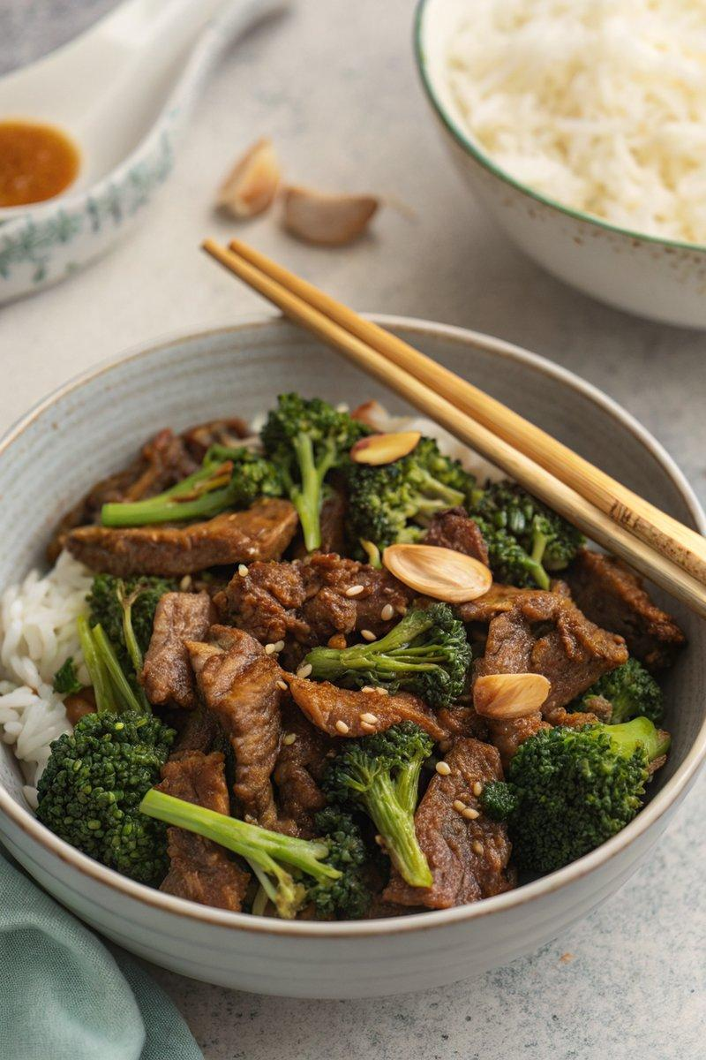

INGREDIENTS  - {'group': 'Main', 'item': '500g skirt or flank steak, sliced thinly against the grain'}  - {'group': 'Main', 'item': '300g tenderstem broccoli, sliced lengthways if thick'}  - {'group': 'Seasoning', 'item': '1 tsp minced ginger'}  - {'group': 'Seasoning', 'item': '2 garlic cloves, minced'}  - {'group': 'Sauce', 'item': '250ml hot beef stock'}  - {'group': 'Sauce', 'item': '3 tbsp light soy sauce'}  - {'group': 'Sauce', 'item': '1 tbsp dark soy sauce'}  - {'group': 'Sauce', 'item': '1 tbsp Chinese rice wine'}  - {'group': 'Sauce', 'item': '2 tsp sesame oil'}  - {'group': 'Sauce', 'item': '3 tbsp light brown sugar'}  - {'group': 'Sauce', 'item': '1/2 tsp ground white pepper'}  - {'group': 'Sauce', 'item': '1/2 tsp ground black pepper'}  - {'group': 'Thickener', 'item': '2 tbsp cornflour mixed with 5 tbsp cold water'}  - {'group': 'For Cooking', 'item': '3 tbsp sunflower oil'}  - {'group': 'For Serving', 'item': 'cooked rice'}  - {'group': 'Garnish', 'item': 'sesame seeds'} | PREP  Slice the beef thinly against the grain. Prepare the broccoli by slicing any thicker pieces lengthways. Mince the ginger and garlic.  COOK  In a bowl, combine all sauce ingredients except the cornflour slurry. Heat 2 tbsp of sunflower oil in a wok over high heat. Stir-fry the beef for 2-3 mins until just cooked, then remove and set aside. Add broccoli to the wok, stir-fry for 2-3 mins, then remove. Reduce heat to medium, add remaining oil, and sauté ginger and garlic for 30 seconds. Increase heat, add sauce mixture, and bring to a boil. Stir in cornflour slurry gradually until sauce thickens. Return beef and broccoli to the wok, toss to coat, and cook for 1 min.  PLATING  Serve the stir-fry over cooked rice and garnish with sesame seeds.

NOTES:
For a more tender cut, you can use sirloin or rib-eye steak, which can be sliced slightly thicker.

