CREAMY TOMATO RAVIOLI WITH SPINACH  COOK TIME: 15 mins  SOURCE: Unknown  #pasta #Italian #one-pan | 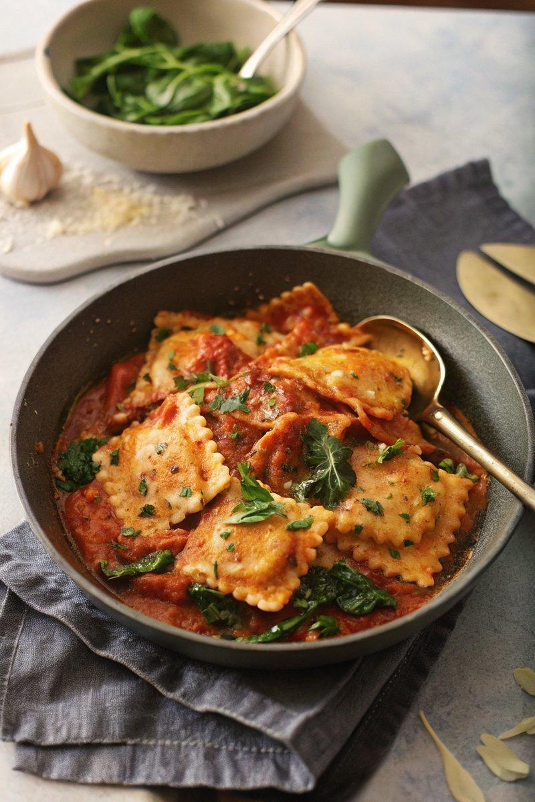

INGREDIENTS  - {'group': 'Main', 'item': '500g fresh ravioli'}  - {'group': 'Main', 'item': '1 tbsp olive oil'}  - {'group': 'Main', 'item': '1 onion, finely diced'}  - {'group': 'Main', 'item': '2 garlic cloves, minced'}  - {'group': 'Main', 'item': '1 red bell pepper, sliced'}  - {'group': 'Seasoning', 'item': '½ tsp Italian herb mix'}  - {'group': 'Seasoning', 'item': '½ tsp chilli flakes'}  - {'group': 'Seasoning', 'item': '1 tsp ground black pepper'}  - {'group': 'Seasoning', 'item': 'pinch of salt'}  - {'group': 'Sauce', 'item': '1 tbsp tomato purée'}  - {'group': 'Sauce', 'item': '90 ml white wine'}  - {'group': 'Sauce', 'item': '100g roasted cherry tomato halves'}  - {'group': 'Sauce', 'item': '120 ml chicken stock'}  - {'group': 'Sauce', 'item': '90 ml double cream'}  - {'group': 'Main', 'item': '90g baby spinach'}  - {'group': 'Garnish', 'item': '50g grated Parmesan'}  - {'group': 'Garnish', 'item': '1 tbsp finely chopped flat-leaf parsley'} | PREP  Peel and finely dice the onion. Mince the garlic cloves. Slice the red bell pepper. Grate the Parmesan cheese and chop the parsley.  COOK  Heat olive oil in a large frying pan over medium heat. Sauté the onion for 4-5 minutes until softened. Add garlic and cook for 30 seconds. Stir in the ravioli and red pepper, cooking for 1 minute. Mix in Italian herbs, chilli flakes, black pepper, and salt. Add tomato purée and white wine, cooking for another minute to reduce. Stir in roasted tomatoes, chicken stock, and cream, bringing to a simmer for 5-6 minutes until ravioli is heated through. Add spinach and Parmesan, cooking until spinach wilts and cheese melts.  PLATING  Serve the ravioli hot, garnished with chopped parsley.

NOTES:
For a vegetarian version, use vegetarian ravioli and replace Parmesan with vegetarian Italian-style hard cheese. If avoiding wine, substitute with additional chicken stock and a teaspoon of lemon juice.

