VEGETABLE PASTA BAKE  COOK TIME: 25 mins  SOURCE: Unknown  #vegetarian #Italian #bake | 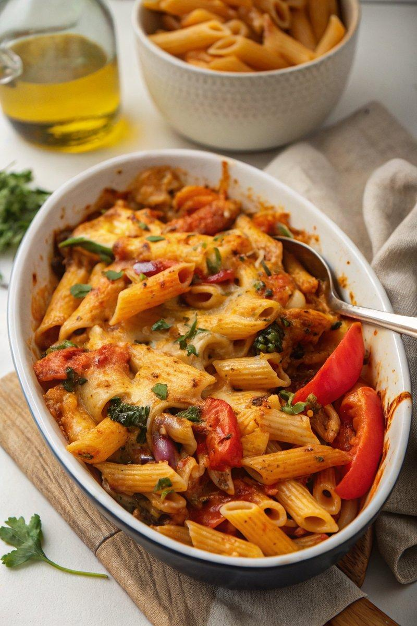

INGREDIENTS  - {'group': 'Main', 'item': '400g dried pasta shapes'}  - {'group': 'Main', 'item': '1 tbsp sunflower oil'}  - {'group': 'Main', 'item': '1 large red onion, chopped into wedges'}  - {'group': 'Main', 'item': '1 red bell pepper, deseeded and chopped'}  - {'group': 'Main', 'item': '1 yellow bell pepper, deseeded and chopped'}  - {'group': 'Main', 'item': '1 large courgette, chopped'}  - {'group': 'Seasoning', 'item': '1/4 tsp salt'}  - {'group': 'Seasoning', 'item': '1/4 tsp ground black pepper'}  - {'group': 'Main', 'item': '2 garlic cloves, minced'}  - {'group': 'Sauce', 'item': '1 tbsp tomato purée'}  - {'group': 'Sauce', 'item': '1/2 tsp dried oregano'}  - {'group': 'Sauce', 'item': '1/2 tsp dried thyme'}  - {'group': 'Sauce', 'item': '2 x 400g cans chopped tomatoes'}  - {'group': 'Sauce', 'item': '120 ml double cream'}  - {'group': 'Main', 'item': '90g fresh baby spinach'}  - {'group': 'Topping', 'item': '100g grated mature Cheddar'}  - {'group': 'Topping', 'item': '100g grated mozzarella'}  - {'group': 'Garnish', 'item': 'A small bunch of flat-leaf parsley, roughly torn'} | PREP  Preheat the oven to 190°C (375°F (190°C)). Bring a large pot of salted water to a boil and cook the pasta for 1 minute less than the package instructions. Drain and set aside.  COOK  In a large frying pan, heat the sunflower oil over medium heat. Sauté the red onion for 3-4 minutes until it begins to soften. Add the bell peppers, courgette, salt, pepper, and garlic. Cook for another 2-3 minutes. Stir in the tomato purée, oregano, thyme, and canned tomatoes. Add the double cream and bring to a gentle simmer. Mix in the cooked pasta and spinach until well combined. Transfer the mixture to a large baking dish.  PLATING  Sprinkle the grated Cheddar and mozzarella over the pasta. Bake in the oven for 20-25 minutes until the cheese is golden brown. Remove from the oven and garnish with fresh parsley before serving.

NOTES:
To make ahead, assemble the dish up to the point of adding cheese, then refrigerate. Reheat covered with foil at 190°C (375°F (190°C)) for 10 minutes, then uncover and bake for an additional 15 minutes.

