CREAMY TUNA PASTA BAKE  COOK TIME: 45 mins  SOURCE: Unknown  #tuna #American #bake | 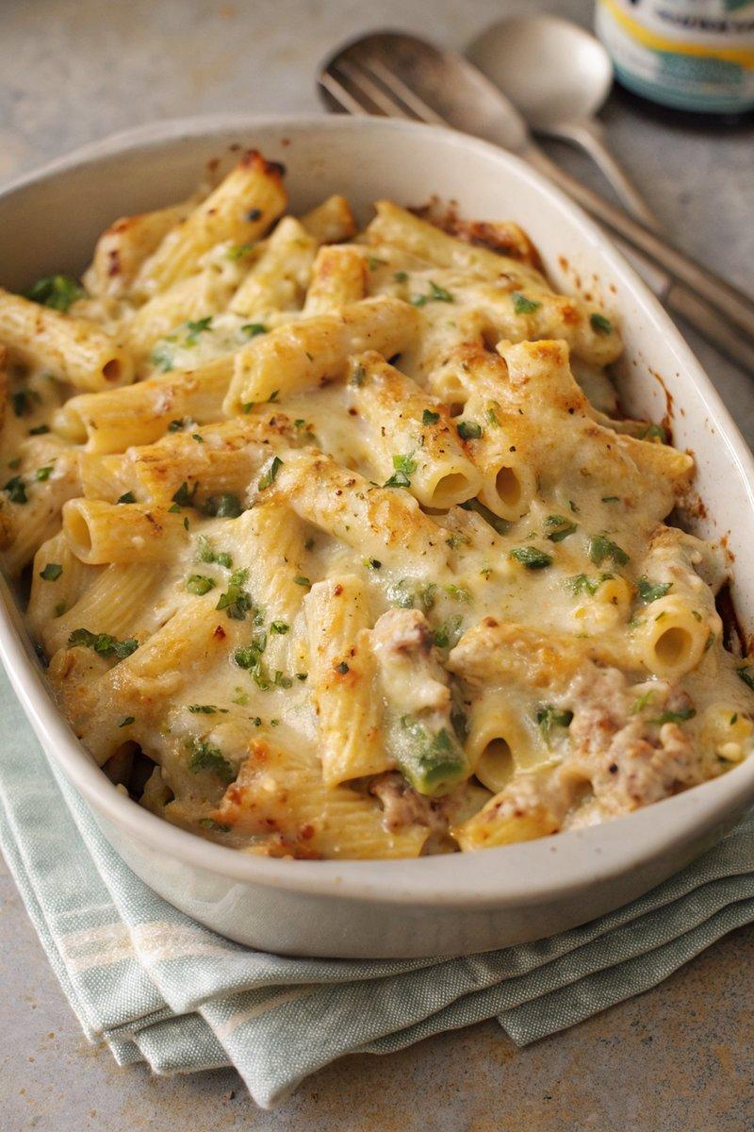

INGREDIENTS  - {'group': 'Main', 'item': '400g pasta'}  - {'group': 'Main', 'item': '320g canned tuna, drained and flaked'}  - {'group': 'Main', 'item': '330g canned sweetcorn, drained'}  - {'group': 'Main', 'item': '150g frozen petits pois'}  - {'group': 'Sauce', 'item': '3 tbsp unsalted butter'}  - {'group': 'Sauce', 'item': '1 onion, peeled and finely chopped'}  - {'group': 'Sauce', 'item': '40g plain flour'}  - {'group': 'Sauce', 'item': '600ml milk'}  - {'group': 'Sauce', 'item': '250g grated mature Cheddar'}  - {'group': 'Seasoning', 'item': '1/4 tsp salt'}  - {'group': 'Seasoning', 'item': '1/4 tsp ground black pepper'}  - {'group': 'Garnish', 'item': '1/2 tsp dried parsley or 2 tbsp chopped flat-leaf parsley'} | PREP  Preheat the oven to 180°C (350°F (175°C)). Bring a large pot of salted water to a boil.  COOK  Cook the pasta in the boiling water for 10 minutes. Meanwhile, melt the butter in a saucepan over low heat and sauté the onion for 6-8 minutes until soft. Increase the heat to medium, stir in the flour, and cook for 1 minute. Gradually whisk in the milk, stirring continuously until the sauce thickens. Add two-thirds of the cheese, stirring until melted, then season with salt and pepper.  PLATING  Drain the pasta and transfer it to a 20x30cm (8x12-inch (30cm (12-inch))) baking dish. Pour the cheese sauce over the pasta, add the tuna, sweetcorn, and petits pois, and mix well. Sprinkle the remaining cheese on top and bake for 15-20 minutes until the cheese is golden brown. Garnish with parsley before serving.

NOTES:
For a richer flavour, use tuna in oil. The dish can be prepared up to the baking step and refrigerated for up to 2 days. Reheat in a preheated oven at 190°C (375°F (190°C)) for 10 minutes covered, then uncover and bake for an additional 20-25 minutes.

