CAJUN CHICKEN AND CHORIZO PASTA  COOK TIME: 25 mins  SOURCE: Unknown  #chicken #American #one-pot | 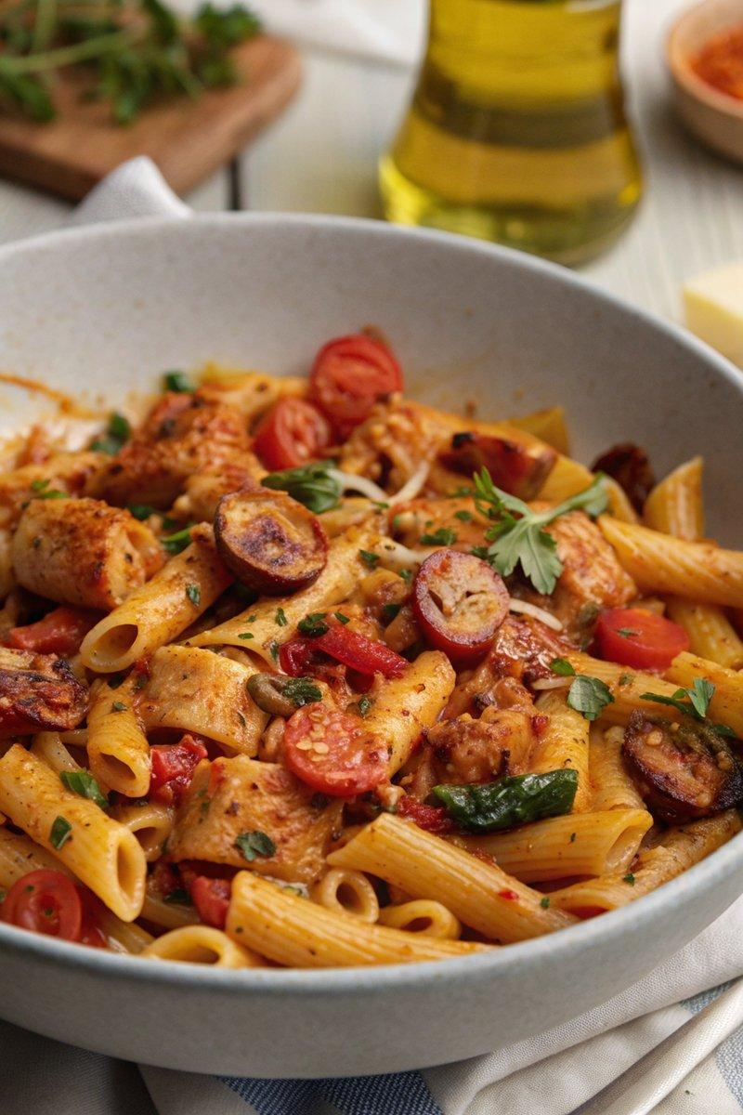

INGREDIENTS  - {'group': 'Main', 'item': '1 tbsp sunflower oil'}  - {'group': 'Main', 'item': '1 onion, peeled and chopped'}  - {'group': 'Main', 'item': '1½ tbsp Cajun seasoning'}  - {'group': 'Main', 'item': '400g chicken breasts, cut into bite-size pieces'}  - {'group': 'Main', 'item': '75g chorizo, cut into small chunks'}  - {'group': 'Main', 'item': '2 garlic cloves, peeled and minced'}  - {'group': 'Main', 'item': '½ red bell pepper, deseeded and sliced'}  - {'group': 'Main', 'item': '½ green bell pepper, deseeded and sliced'}  - {'group': 'Main', 'item': '½ yellow bell pepper, deseeded and sliced'}  - {'group': 'Main', 'item': '200g dried pasta shapes'}  - {'group': 'Main', 'item': '400g can chopped tomatoes'}  - {'group': 'Main', 'item': '480ml chicken stock'}  - {'group': 'Main', 'item': '80ml double cream'}  - {'group': 'Main', 'item': 'A large handful of baby spinach'}  - {'group': 'Garnish', 'item': '10 cherry tomatoes, sliced in half'}  - {'group': 'Garnish', 'item': '50g grated Cheddar'}  - {'group': 'Garnish', 'item': 'Chopped flat-leaf parsley'} | PREP  Peel and chop the onion. Slice the bell peppers and cherry tomatoes. Mince the garlic. Cut the chicken breasts into bite-size pieces and the chorizo into small chunks.  COOK  Heat the sunflower oil in a large frying pan over medium heat. Sauté the onion for 5 minutes until softened. Sprinkle Cajun seasoning over the chicken pieces and add them to the pan, cooking for 5-6 minutes until browned. Add the chorizo and garlic, cooking for another 2 minutes until the chorizo releases its oils. Stir in the sliced bell peppers, pasta, chopped tomatoes, and chicken stock. Bring to a boil, then cover and simmer for 15 minutes, stirring occasionally. Check the pasta for doneness, adding a splash of boiling water if needed. Stir in the cream and heat through for a minute, then add the spinach to wilt.  PLATING  Serve the pasta hot, garnished with sliced cherry tomatoes, grated Cheddar, and chopped parsley.

NOTES:
For a vegetarian version, replace chicken with tofu or roasted butternut squash, and use vegetable stock. Omit the chorizo or substitute with vegetarian sausage, adding smoked paprika for a smoky flavour.

