ONE-POT CHEESY CHICKEN PASTA  COOK TIME: 25 mins  SOURCE: Unknown  #chicken #Italian #one-pot | 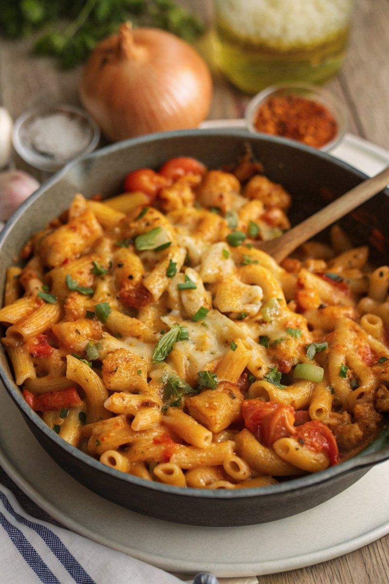

INGREDIENTS  - {'group': 'Main', 'item': '1 tbsp sunflower oil'}  - {'group': 'Main', 'item': '1 large onion, peeled and chopped'}  - {'group': 'Main', 'item': '2 chicken breasts (400g), cut into chunks'}  - {'group': 'Seasoning', 'item': 'a pinch of salt and pepper'}  - {'group': 'Main', 'item': '2 garlic cloves, peeled and minced'}  - {'group': 'Main', 'item': '1 tbsp tomato purée'}  - {'group': 'Main', 'item': '1 red bell pepper, deseeded and chopped'}  - {'group': 'Main', 'item': '300g dried pasta shapes'}  - {'group': 'Seasoning', 'item': '1 tsp dried oregano'}  - {'group': 'Sauce', 'item': '½ tbsp Worcestershire sauce'}  - {'group': 'Sauce', 'item': '2 x 400g cans chopped tomatoes'}  - {'group': 'Sauce', 'item': '300 ml chicken stock'}  - {'group': 'Sauce', 'item': '120 ml milk'}  - {'group': 'Main', 'item': '20 sugar snap peas, roughly chopped'}  - {'group': 'Topping', 'item': '100g grated mature Cheddar'}  - {'group': 'Garnish', 'item': '1 tbsp chopped flat-leaf parsley'} | PREP  Peel and chop the onion, mince the garlic, deseed and chop the red bell pepper, and roughly chop the sugar snap peas. Cut the chicken breasts into chunks.  COOK  Heat the sunflower oil in a large frying pan over medium-high heat. Sauté the onion for about 3 minutes until it begins to soften. Add the chicken chunks, season with salt and pepper, and cook for another 3 minutes until the chicken is sealed. Stir in the garlic, tomato purée, and red pepper, then add the dried pasta. Pour in the oregano, Worcestershire sauce, chopped tomatoes, chicken stock, and milk. Stir well, bring to a boil, then reduce to a gentle simmer. Cover and cook for 12-15 minutes, stirring occasionally, until the pasta is tender. Add the sugar snap peas and cook for an additional 2 minutes.  PLATING  Sprinkle the pasta with grated Cheddar cheese and place under a grill for a couple of minutes until the cheese melts. Garnish with chopped parsley and serve immediately.

NOTES:
For an extra cheesy finish, consider adding some grated mozzarella along with the Cheddar before grilling.

