CAJUN CHICKEN PASTA WITH CREAMY HOT PEPPER SAUCE  COOK TIME: 15 mins  SOURCE: Unknown  #chicken #American #pan-fry | 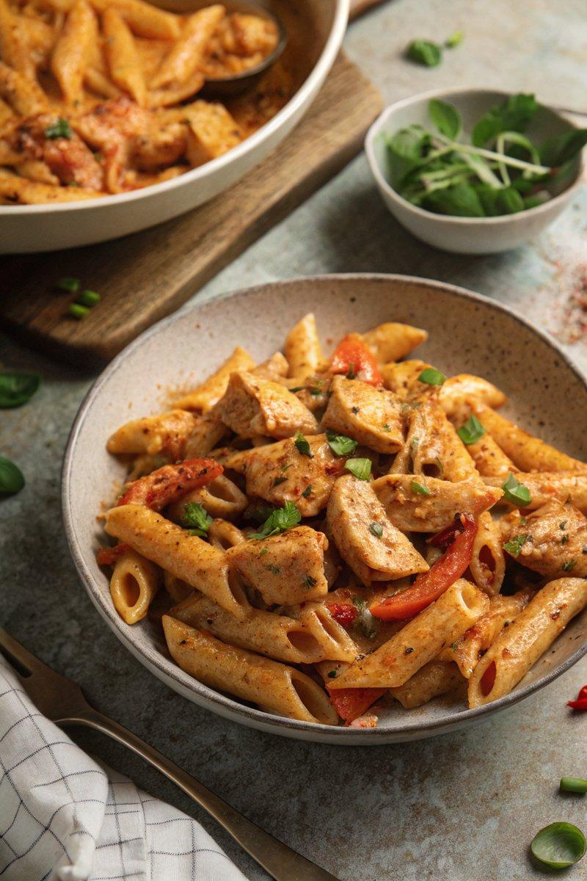

INGREDIENTS  - {'group': 'Main', 'item': '300g pasta shapes, such as penne'}  - {'group': 'Main', 'item': '1 tbsp sunflower oil'}  - {'group': 'Main', 'item': '600g chicken breasts, chopped into bite-size pieces'}  - {'group': 'Seasoning', 'item': '1 tbsp Cajun spice mix'}  - {'group': 'Seasoning', 'item': '½ tsp ground black pepper'}  - {'group': 'Seasoning', 'item': '1 chicken stock cube, crumbled'}  - {'group': 'Main', 'item': '2 garlic cloves, minced'}  - {'group': 'Main', 'item': '1 onion, sliced'}  - {'group': 'Main', 'item': '1 red bell pepper, sliced'}  - {'group': 'Main', 'item': '1 yellow bell pepper, sliced'}  - {'group': 'Main', 'item': '2 jalapeños, sliced'}  - {'group': 'Sauce', 'item': '60 ml hot pepper sauce'}  - {'group': 'Sauce', 'item': '1 tbsp Worcestershire sauce'}  - {'group': 'Sauce', 'item': '1 tbsp cider vinegar'}  - {'group': 'Sauce', 'item': '120 ml double cream'}  - {'group': 'Sauce', 'item': '50g grated Parmesan cheese'}  - {'group': 'Garnish', 'item': 'sliced jalapeños'}  - {'group': 'Garnish', 'item': 'sliced spring onions'} | PREP  Slice the chicken breasts into bite-size pieces. Mince the garlic, slice the onion, red and yellow bell peppers, and jalapeños. Crumble the chicken stock cube.  COOK  Cook the pasta according to package instructions, then drain and reserve 240ml of the cooking water. In a large frying pan, heat the sunflower oil over medium-high heat. Add the chicken pieces, sprinkle with Cajun spice and black pepper, and cook for about 5 minutes until nearly cooked through. Add the crumbled stock cube, garlic, onion, bell peppers, and jalapeños, cooking for another 3-4 minutes until the onion softens. Stir in the hot pepper sauce, Worcestershire sauce, cider vinegar, cream, and Parmesan cheese, bringing the mixture to a simmer for 3-4 minutes until the chicken is fully cooked.  PLATING  Combine the cooked pasta with the chicken and sauce in the pan, tossing to coat. If needed, add reserved pasta water to loosen the sauce. Serve in bowls, garnished with sliced jalapeños and spring onions.

NOTES:
For a variation, try using half Parmesan and adding crumbled Lancashire or aged Cheddar before serving. Blue cheese like Stilton can also be a great addition for those who enjoy it.

