CLASSIC SPAGHETTI BOLOGNESE  COOK TIME: 25 mins  SOURCE: Unknown  #beef #italian #simmer | 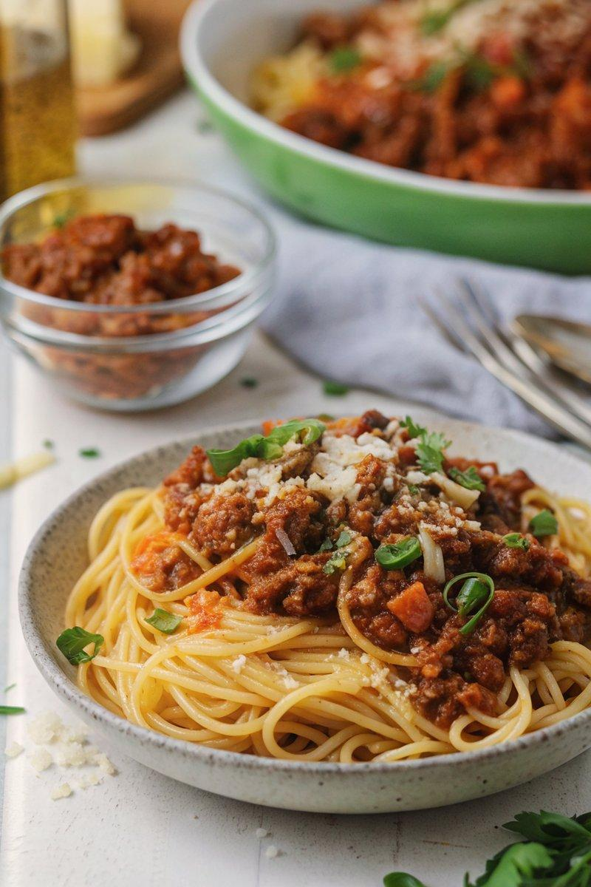

INGREDIENTS  - {'group': 'Main', 'item': '1 tbsp olive oil'}  - {'group': 'Main', 'item': '1 onion, finely diced'}  - {'group': 'Main', 'item': '2 garlic cloves, minced'}  - {'group': 'Main', 'item': '1 carrot, finely diced'}  - {'group': 'Main', 'item': '3 chestnut mushrooms, finely diced'}  - {'group': 'Main', 'item': '450g minced beef'}  - {'group': 'Sauce', 'item': '120ml red wine'}  - {'group': 'Sauce', 'item': '3 tbsp tomato purée'}  - {'group': 'Sauce', 'item': '1 tsp dried oregano'}  - {'group': 'Sauce', 'item': '½ tsp dried thyme'}  - {'group': 'Sauce', 'item': '1 tbsp Worcestershire sauce'}  - {'group': 'Sauce', 'item': '1 beef stock cube, crumbled'}  - {'group': 'Sauce', 'item': '800g canned chopped tomatoes'}  - {'group': 'Sauce', 'item': '½ tbsp light brown sugar'}  - {'group': 'Seasoning', 'item': '½ tsp salt'}  - {'group': 'Seasoning', 'item': '½ tsp ground black pepper'}  - {'group': 'For Serving', 'item': '300g dried spaghetti'}  - {'group': 'Garnish', 'item': 'Chopped spring onions'}  - {'group': 'Garnish', 'item': 'Grated Parmesan'} | PREP  Peel and finely dice the onion and carrot. Mince the garlic and dice the mushrooms.  COOK  Heat olive oil in a skillet over medium-high heat. Sauté the onion for 5 mins until softened. Add garlic, cooking for 1 min, then add carrot and mushrooms, cooking for another 2-3 mins. Stir in minced beef, breaking it up, and cook until browned, about 5-6 mins. Pour in red wine, bring to a boil, and reduce by three-quarters. Mix in tomato purée, oregano, thyme, Worcestershire sauce, beef stock cube, chopped tomatoes, brown sugar, salt, and pepper. Bring to a boil, then simmer for 15-20 mins until thickened. Meanwhile, cook spaghetti in salted boiling water for 10-12 mins until al dente.  PLATING  Drain the spaghetti and divide among bowls. Top with bolognese sauce and garnish with chopped spring onions and grated Parmesan before serving.

NOTES:
For a non-alcoholic version, replace red wine with 120ml beef stock and an extra splash of Worcestershire sauce. The bolognese sauce can be made ahead and stored in the refrigerator or freezer.

