FOUR CHEESE MACARONI WITH BACON  COOK TIME: 35 mins  SOURCE: Unknown  #pasta #american #baked | 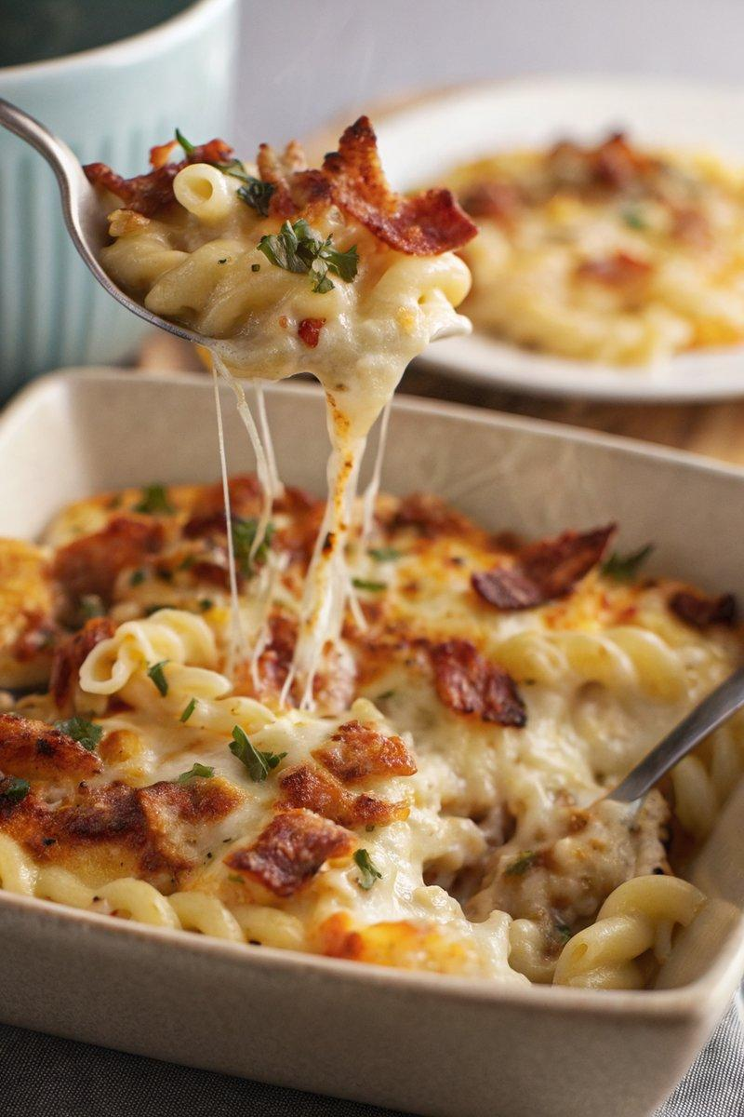

INGREDIENTS  - {'group': 'Main', 'item': '200g spiral pasta'}  - {'group': 'Main', 'item': '60g unsalted butter'}  - {'group': 'Main', 'item': '60g plain flour'}  - {'group': 'Main', 'item': '480ml milk'}  - {'group': 'Main', 'item': '75g grated mature Cheddar'}  - {'group': 'Main', 'item': '75g grated Gouda'}  - {'group': 'Main', 'item': '75g grated mozzarella'}  - {'group': 'Main', 'item': '50g grated Parmesan'}  - {'group': 'Main', 'item': '6 rashers bacon, roughly chopped'}  - {'group': 'Seasoning', 'item': '½ tsp salt'}  - {'group': 'Seasoning', 'item': '½ tsp ground black pepper'}  - {'group': 'Garnish', 'item': '2 tbsp chopped flat-leaf parsley'} | PREP  Preheat the oven to 200°C (400°F (200°C)). Lightly grill the bacon and chop it roughly. Grate all the cheeses and chop the parsley.  COOK  Boil the pasta in salted water for 1 minute less than the package instructions, then drain. In a saucepan over medium heat, melt the butter and whisk in the flour, cooking for 1-2 minutes. Gradually add the milk, whisking continuously until smooth and thickened. Stir in the salt, pepper, and all cheeses except for a tablespoon of each, then remove from heat. Combine the pasta with the cheese sauce.  PLATING  Transfer the pasta mixture to a baking dish, sprinkle with reserved cheeses and bacon. Bake for 15-20 minutes until golden brown. Garnish with parsley before serving.

NOTES:
Feel free to use your preferred pasta shape if spiral pasta is unavailable.

