SPICY SAUSAGE RIGATONI WITH TOMATO AND BASIL  COOK TIME: 20 mins  SOURCE: Unknown  #pork #Italian #pan-fry | 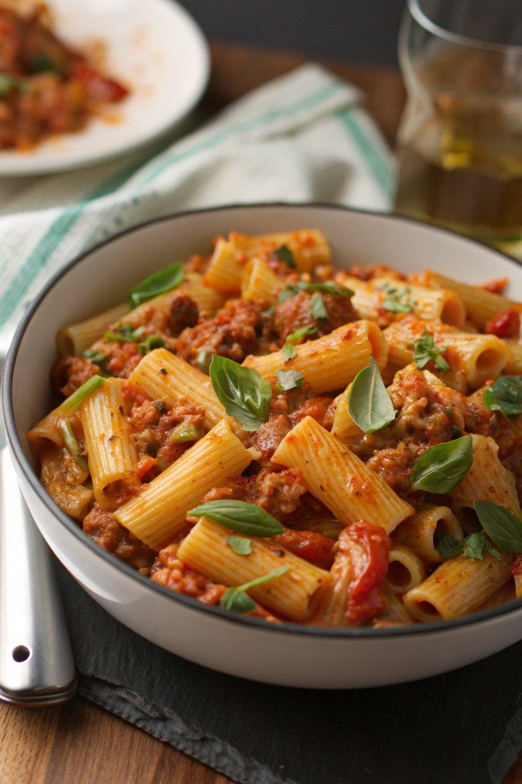

INGREDIENTS  - {'group': 'Main', 'item': '300g dried rigatoni pasta'}  - {'group': 'Main', 'item': '2 tbsp olive oil'}  - {'group': 'Main', 'item': '1 small onion, finely diced'}  - {'group': 'Main', 'item': '1 red bell pepper, finely chopped'}  - {'group': 'Main', 'item': '2 garlic cloves, minced'}  - {'group': 'Main', 'item': '1 red or green chilli, finely chopped'}  - {'group': 'Main', 'item': '400g pork sausages, skins removed'}  - {'group': 'Sauce', 'item': '2 tbsp tomato purée'}  - {'group': 'Sauce', 'item': '¼ tsp ground black pepper'}  - {'group': 'Sauce', 'item': '½ tsp chilli flakes'}  - {'group': 'Sauce', 'item': '1 tsp dried oregano'}  - {'group': 'Sauce', 'item': '400g can finely chopped tomatoes'}  - {'group': 'Sauce', 'item': '¼ tsp salt (optional)'}  - {'group': 'Sauce', 'item': '60 ml double cream'}  - {'group': 'Garnish', 'item': 'A small bunch of basil, sliced into strips'}  - {'group': 'Garnish', 'item': 'Grated Parmesan, to serve'} | PREP  Peel and finely dice the onion. Chop the red bell pepper and mince the garlic. Finely chop the chilli and remove the skins from the sausages.  COOK  Cook the rigatoni according to package instructions, then drain and reserve 240ml of the pasta water. In a large frying pan, heat olive oil over medium-high heat. Sauté the onion, red pepper, garlic, and chilli for about 5 minutes until the onion softens. Add the sausage meat, breaking it up with a spoon, and cook until browned, about 5-6 minutes. Stir in the tomato purée, black pepper, chilli flakes, and oregano, then add the chopped tomatoes. Bring to a boil, then simmer for 5 minutes. Taste and adjust seasoning if necessary.  PLATING  Combine the cooked pasta with the sauce, adding cream and half the basil. Stir well, adding reserved pasta water to loosen the sauce if needed. Heat through for 1-2 minutes. Serve topped with remaining basil and grated Parmesan.

NOTES:
Experiment with different sausage flavours for variety. To make it vegetarian, use vegetarian sausages and replace Parmesan with a vegetarian alternative.

