VEGETARIAN MUSHROOM CHOW MEIN  COOK TIME: 20 mins  SOURCE: Unknown  #vegetarian #asian #stir-fry | 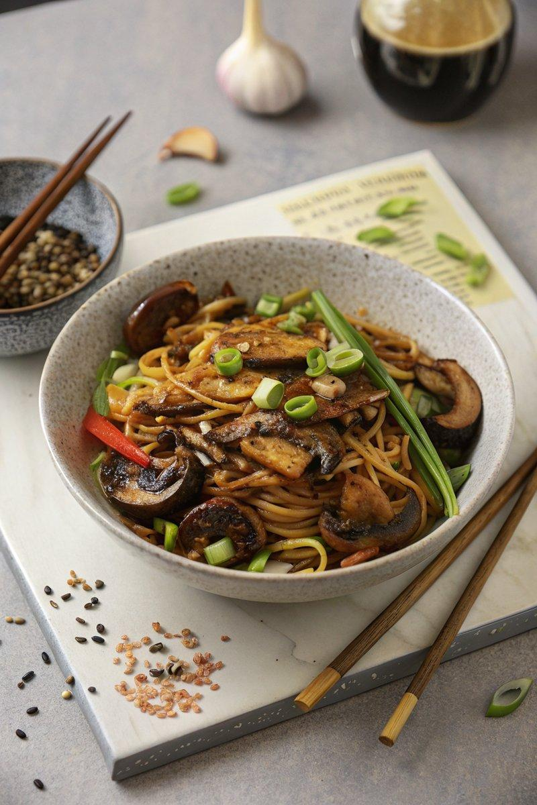

INGREDIENTS  - {'group': 'Main', 'item': '200g dried chow mein noodles'}  - {'group': 'Main', 'item': '3 tbsp sunflower oil'}  - {'group': 'Main', 'item': '400g chestnut mushrooms, sliced'}  - {'group': 'Main', 'item': '1 onion, peeled and sliced'}  - {'group': 'Main', 'item': '2 garlic cloves, minced'}  - {'group': 'Main', 'item': '1 large carrot, sliced into matchsticks'}  - {'group': 'Main', 'item': '1 red bell pepper, deseeded and sliced'}  - {'group': 'Main', 'item': '½ savoy cabbage, thinly sliced'}  - {'group': 'Main', 'item': '200g beansprouts'}  - {'group': 'Main', 'item': '10 spring onions, cut into 5cm lengths'}  - {'group': 'Sauce', 'item': '1 tbsp cornflour'}  - {'group': 'Sauce', 'item': '2 tbsp dark soy sauce'}  - {'group': 'Sauce', 'item': '1 tbsp Chinese rice wine'}  - {'group': 'Sauce', 'item': '2 tbsp kecap manis'}  - {'group': 'Sauce', 'item': '2 tbsp hoisin sauce'}  - {'group': 'Sauce', 'item': '90ml vegetable stock'}  - {'group': 'Sauce', 'item': '1 tbsp sesame oil'}  - {'group': 'Sauce', 'item': '¼ tsp white pepper'}  - {'group': 'Garnish', 'item': '2 spring onions, roughly chopped'}  - {'group': 'Garnish', 'item': '1 tsp sesame seeds'}  - {'group': 'Garnish', 'item': '¼ tsp chilli flakes'} | PREP  Prepare the chow mein sauce by mixing cornflour, soy sauce, and Chinese rice wine in a small bowl until smooth. Add kecap manis, hoisin sauce, vegetable stock, sesame oil, and white pepper, stirring to combine. Set aside. Boil the chow mein noodles according to package instructions, then drain and rinse under cold water.  COOK  Heat sunflower oil in a wok over high heat. Add sliced mushrooms, season with salt and pepper, and stir-fry for 3 minutes until softened. Add onion, garlic, and carrot, continuing to stir-fry for another 3 minutes. Incorporate red pepper, cabbage, beansprouts, and spring onions, stir-frying for 2 more minutes. Add the cooked noodles and pour over the prepared sauce. Stir-fry everything together for 2-3 minutes until the noodles are heated through.  PLATING  Serve the chow mein hot, garnished with chopped spring onions, sesame seeds, and a sprinkle of chilli flakes for added heat.

NOTES:
Feel free to substitute vegetables with your favourites, such as sugar snap peas or green beans.

