VEGETARIAN EGG-FRIED RICE  COOK TIME: 15 mins  SOURCE: Unknown  #vegetarian #asian #stir-fry | 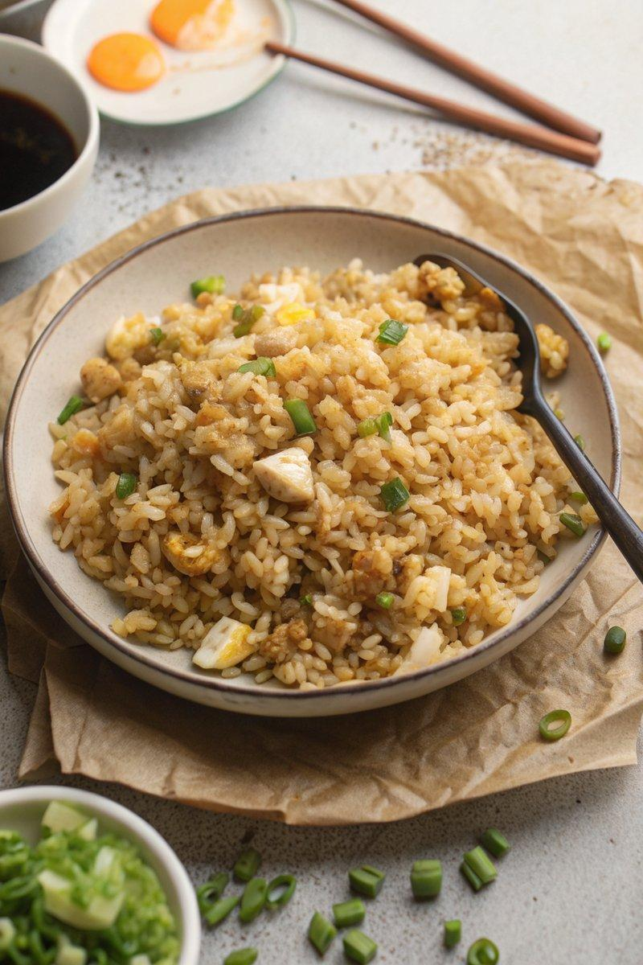

INGREDIENTS  - {'group': 'Main', 'item': '2 tbsp sunflower oil'}  - {'group': 'Main', 'item': '1 onion, peeled and diced'}  - {'group': 'Main', 'item': '2 garlic cloves, peeled and minced'}  - {'group': 'Main', 'item': '800g boiled and cooled long-grain rice'}  - {'group': 'Main', 'item': '½ tbsp sesame oil'}  - {'group': 'Main', 'item': '2 eggs'}  - {'group': 'Sauce', 'item': '2 tbsp dark soy sauce'}  - {'group': 'Seasoning', 'item': '¼ tsp salt'}  - {'group': 'Seasoning', 'item': '¼ tsp garlic salt'}  - {'group': 'Seasoning', 'item': '1 tbsp lemon juice'}  - {'group': 'Garnish', 'item': '½ bunch spring onions, chopped'} | PREP  Dice the onion and mince the garlic. Boil and cool the long-grain rice if not already prepared. Chop the spring onions for garnish.  COOK  Heat 1 tbsp of sunflower oil in a large wok over medium heat. Add the diced onion and sauté for about 5 mins until soft and translucent. Stir in the garlic and cook for another 30 seconds. Increase the heat to high, add the remaining sunflower oil, and toss in the cooled rice. Drizzle with sesame oil and stir-fry for about 5 mins until the rice is hot. Push the rice to one side of the wok and crack the eggs into the empty space. Add 1 tbsp of soy sauce to the eggs and scramble them until just set but still slightly runny. Mix the scrambled eggs into the rice, then add the remaining soy sauce, salt, garlic salt, and lemon juice. Stir everything together thoroughly.  PLATING  Divide the egg-fried rice among four bowls and garnish with chopped spring onions before serving.

NOTES:
Ensure the rice is cold before frying to prevent it from becoming sticky. Adjust the lemon juice to taste.

