CRISPY SESAME CHICKEN WITH SWEET AND SPICY SAUCE  COOK TIME: 15 mins  SOURCE: Unknown  #chicken #asian #pan-fry | 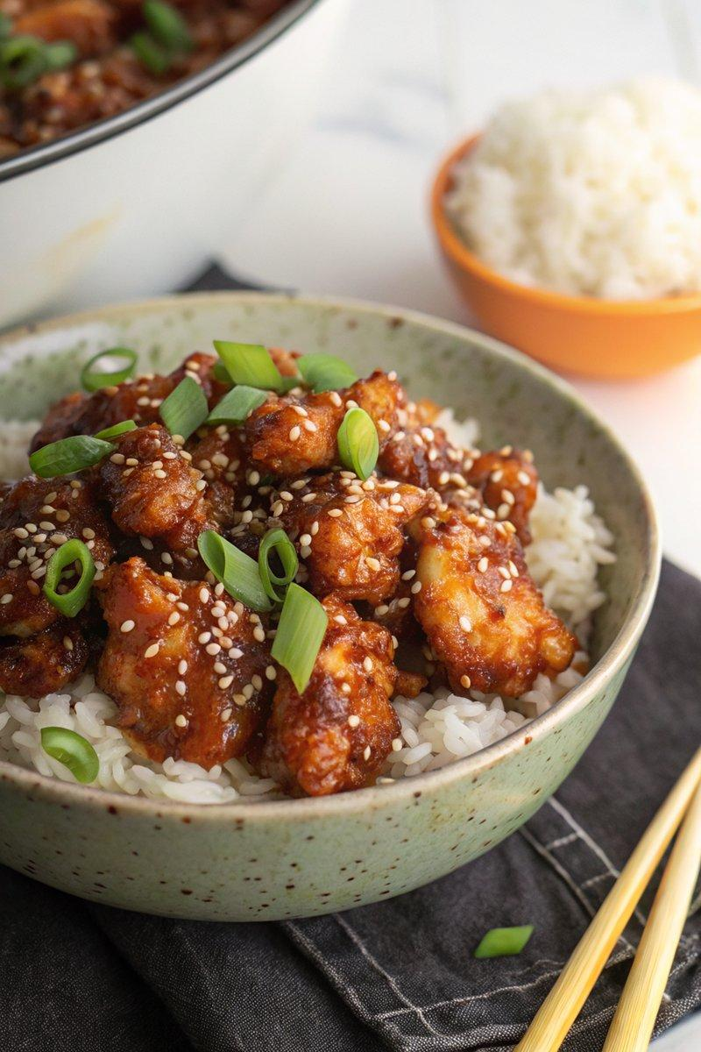

INGREDIENTS  - {'group': 'Main', 'item': '600g chicken breasts, chopped into bite-size chunks'}  - {'group': 'Coating', 'item': '2 eggs, lightly beaten'}  - {'group': 'Coating', 'item': '3 tbsp cornflour'}  - {'group': 'Coating', 'item': '75g plain flour'}  - {'group': 'Coating', 'item': '1/2 tsp salt'}  - {'group': 'Coating', 'item': '1/2 tsp ground black pepper'}  - {'group': 'Coating', 'item': '1/2 tsp garlic salt'}  - {'group': 'Coating', 'item': '2 tsp paprika'}  - {'group': 'Sauce', 'item': '1 tbsp sesame oil'}  - {'group': 'Sauce', 'item': '2 garlic cloves, minced'}  - {'group': 'Sauce', 'item': '1 tbsp Chinese rice vinegar'}  - {'group': 'Sauce', 'item': '2 tbsp honey'}  - {'group': 'Sauce', 'item': '2 tbsp sweet chilli sauce'}  - {'group': 'Sauce', 'item': '3 tbsp ketchup'}  - {'group': 'Sauce', 'item': '2 tbsp brown sugar'}  - {'group': 'Sauce', 'item': '4 tbsp soy sauce'}  - {'group': 'Garnish', 'item': '2 tbsp sesame seeds'}  - {'group': 'Garnish', 'item': 'A small bunch of spring onions, chopped'}  - {'group': 'For Serving', 'item': 'Cooked rice'} | PREP  Prepare three shallow bowls: one with beaten eggs, one with cornflour, and one with a mixture of plain flour, salt, pepper, garlic salt, and paprika. Chop the chicken into bite-size pieces.  COOK  Heat 5 tbsp sunflower oil in a wok over high heat. Dredge chicken pieces in cornflour, dip in egg, then coat with seasoned flour. Fry in batches for 6-7 mins until golden brown, turning occasionally. Remove and drain on paper towels. In the same wok, add sesame oil and minced garlic, sauté briefly. Add rice vinegar, honey, sweet chilli sauce, ketchup, brown sugar, and soy sauce. Stir and simmer until reduced by a third, about 2-3 mins. Return chicken to the wok, toss to coat, and cook for an additional 1-2 mins.  PLATING  Serve the crispy sesame chicken over cooked rice. Garnish with sesame seeds and chopped spring onions.

NOTES:
For extra sauce to drizzle over rice, consider doubling the sauce ingredients.

