SWEET AND SOUR CHICKEN WITH CRISPY COATING  COOK TIME: 15 mins  SOURCE: Unknown  #chicken #Asian #pan-fry | 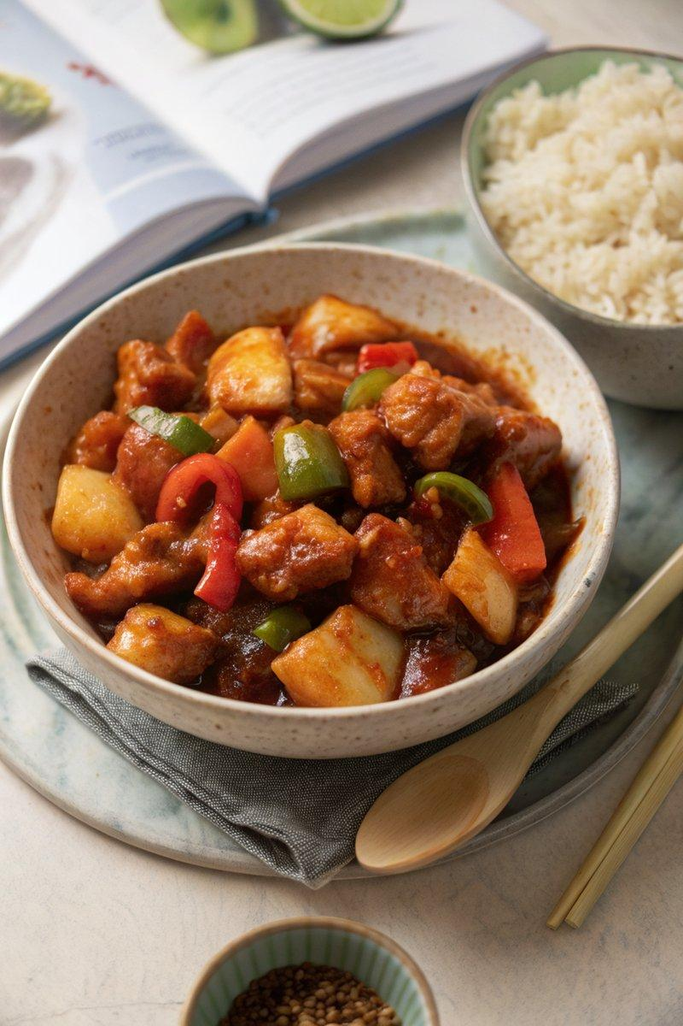

INGREDIENTS  - {'group': 'Main', 'item': '3 chicken breasts, chopped into bite-size chunks'}  - {'group': 'Main', 'item': '5 tbsp sunflower oil'}  - {'group': 'Main', 'item': '2 eggs, lightly beaten'}  - {'group': 'Main', 'item': '3 tbsp cornflour'}  - {'group': 'Main', 'item': '90g plain flour'}  - {'group': 'Main', 'item': '½ tsp salt'}  - {'group': 'Main', 'item': '½ tsp ground black pepper'}  - {'group': 'Main', 'item': '½ tsp garlic salt'}  - {'group': 'Main', 'item': '2 tsp paprika'}  - {'group': 'Sauce', 'item': '1 tbsp sunflower oil'}  - {'group': 'Sauce', 'item': '1 large onion, chopped'}  - {'group': 'Sauce', 'item': '1 red bell pepper, chopped'}  - {'group': 'Sauce', 'item': '1 green bell pepper, chopped'}  - {'group': 'Sauce', 'item': '2 garlic cloves, minced'}  - {'group': 'Sauce', 'item': '1 tsp minced ginger'}  - {'group': 'Sauce', 'item': '150 ml tomato ketchup'}  - {'group': 'Sauce', 'item': '1 tbsp tomato purée'}  - {'group': 'Sauce', 'item': '2 tbsp malt vinegar'}  - {'group': 'Sauce', 'item': '6 tbsp dark brown muscovado sugar'}  - {'group': 'Sauce', 'item': '475g canned pineapple chunks in juice'} | PREP  Chop the chicken breasts into bite-size chunks. In separate shallow bowls, place the beaten eggs, cornflour, and a mixture of plain flour, salt, pepper, garlic salt, and paprika.  COOK  Heat 5 tbsp of sunflower oil in a wok over high heat. Dredge chicken pieces in cornflour, dip in egg, then coat with seasoned flour. Fry in batches for 6-7 mins until golden brown. In another pan, heat 1 tbsp oil and sauté onion for 3 mins. Add bell peppers, cooking for 1 min, then add garlic and ginger for another minute. Stir in ketchup, tomato purée, vinegar, sugar, and pineapple with juice. Bring to a boil, reduce heat, and simmer until thickened. Toss fried chicken in the sauce and cook for 2 mins.  PLATING  Serve the sweet and sour chicken hot with a side of boiled or fried rice.

NOTES:
Ensure the chicken is cooked immediately before adding to the sauce to maintain the crispiness of the coating.

