HONEY GARLIC CHICKEN THIGHS  COOK TIME: 15 mins  SOURCE: Unknown  #chicken #asian #pan-fry | 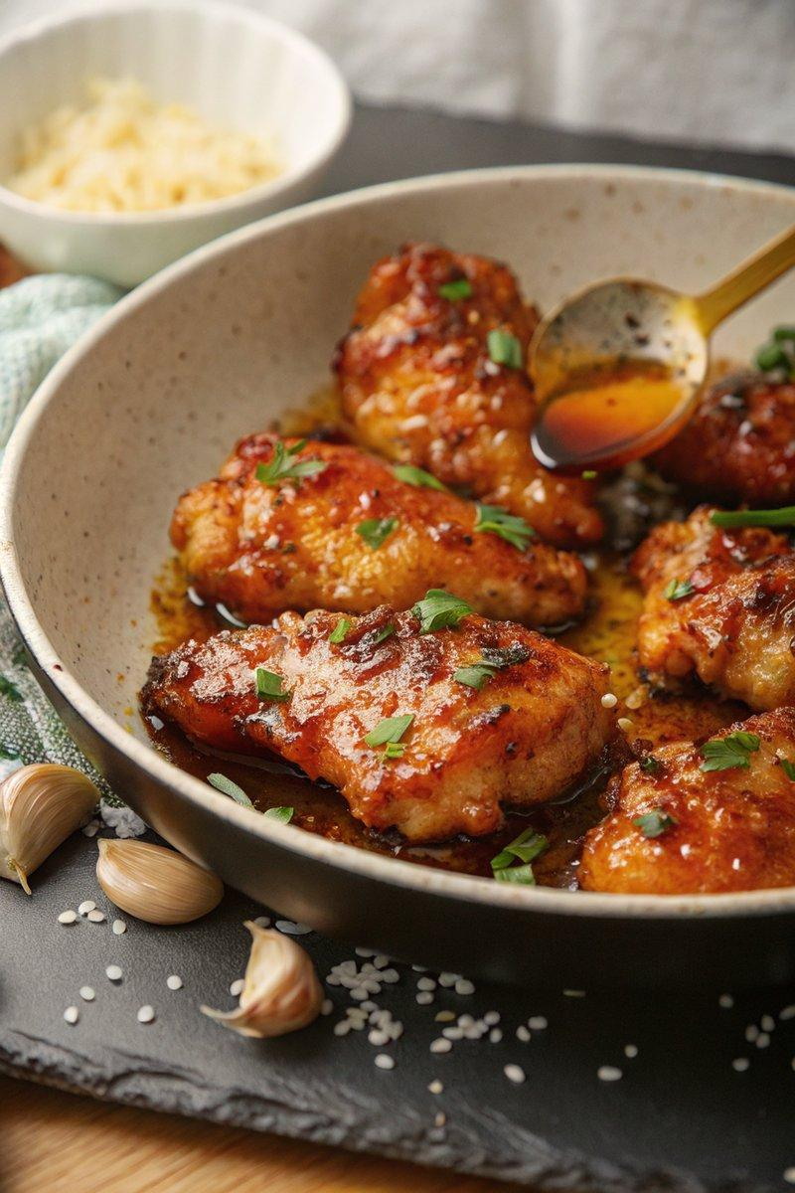

INGREDIENTS  - {'group': 'Main', 'item': '8 skinless chicken thigh fillets (about 720g)'}  - {'group': 'Main', 'item': '2 tbsp cornflour'}  - {'group': 'Main', 'item': '1/2 tsp salt'}  - {'group': 'Main', 'item': '1/2 tsp ground black pepper'}  - {'group': 'Main', 'item': '2 tbsp sunflower oil'}  - {'group': 'Main', 'item': '1 tbsp unsalted butter'}  - {'group': 'Sauce', 'item': '4 garlic cloves, minced'}  - {'group': 'Sauce', 'item': '120ml honey'}  - {'group': 'Sauce', 'item': '80ml chicken stock'}  - {'group': 'Sauce', 'item': '1 tbsp rice vinegar'}  - {'group': 'Sauce', 'item': '1 tbsp light soy sauce'}  - {'group': 'Garnish', 'item': '1 tbsp finely chopped flat-leaf parsley'}  - {'group': 'Garnish', 'item': '1/2 tsp chilli flakes'}  - {'group': 'For Serving', 'item': 'cooked rice'} | PREP  In a bowl, combine chicken thighs with cornflour, salt, and pepper, ensuring they are evenly coated.  COOK  Heat sunflower oil in a large frying pan over high heat. Add the chicken thighs and cook until golden brown on one side, about 4-5 mins. Flip and cook for another 2 mins. Reduce heat to medium, add butter and garlic, stirring until fragrant. In a separate bowl, mix honey, chicken stock, rice vinegar, and soy sauce. Pour the sauce into the pan, increase heat to bring to a boil, then simmer for 4-5 mins until the sauce thickens and the chicken is cooked through.  PLATING  Serve the chicken over cooked rice, garnished with chopped parsley and chilli flakes.

NOTES:
If rice vinegar is unavailable, substitute with cider vinegar or white wine vinegar plus 1/4 tsp sugar.

