CRISPY OVEN-ROASTED DUCK WITH PLUM GLAZE  COOK TIME: 3 hrs 40 mins  SOURCE: Unknown  #duck #Asian #roast | 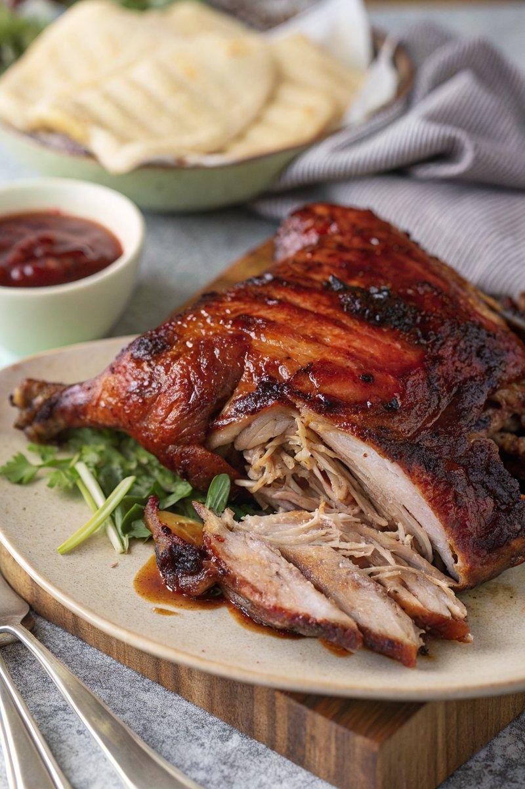

INGREDIENTS  - {'group': 'Main', 'item': '1 duck (about 2.4kg), innards removed'}  - {'group': 'Seasoning', 'item': '½ tsp salt'}  - {'group': 'Seasoning', 'item': '½ tsp ground black pepper'}  - {'group': 'Glaze', 'item': '2 tbsp plum sauce'}  - {'group': 'For Serving', 'item': '12 Chinese pancakes, warmed'}  - {'group': 'For Serving', 'item': '1 bunch spring onions, sliced into thin strips'}  - {'group': 'For Serving', 'item': '1 cucumber, sliced into thin strips'} | PREP  Preheat the oven to 150°C (300°F (150°C)). Pat the duck dry with kitchen paper and score the skin in a criss-cross pattern, being careful not to cut into the flesh.  COOK  Place the duck breast-side up on a wire rack in a roasting tin. Season with salt and pepper. Roast in the oven for 3 hours and 30 minutes, turning the duck every hour to ensure even cooking and crisp skin. After this time, increase the oven temperature to 190°C (375°F (190°C)). Brush the duck with plum sauce and return to the oven for an additional 10 minutes until the glaze is dark brown and caramelized.  PLATING  Let the duck rest for 10 minutes before shredding the meat with two forks. Serve immediately with additional plum sauce, warm pancakes, and strips of spring onion and cucumber.

NOTES:
Turning the duck regularly helps distribute the fat evenly, enhancing the crispiness of the skin.

