PRAWN BALTI CURRY  COOK TIME: 15 mins  SOURCE: Unknown  #prawn #Indian #sauté | 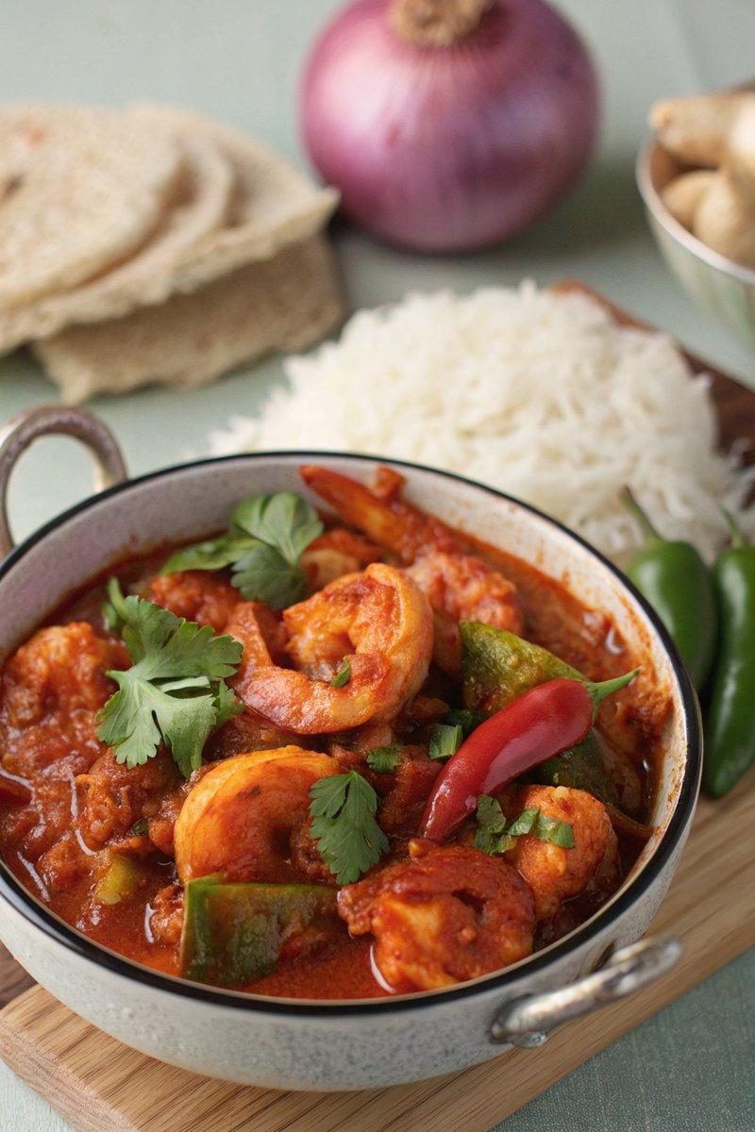

INGREDIENTS  - {'group': 'Main', 'item': '20-25 raw king prawns, shelled and deveined'}  - {'group': 'Main', 'item': '1 large onion, chopped'}  - {'group': 'Main', 'item': '1 red bell pepper, chopped'}  - {'group': 'Main', 'item': '1 green bell pepper, chopped'}  - {'group': 'Main', 'item': '2 garlic cloves, minced'}  - {'group': 'Main', 'item': '2 tsp minced ginger'}  - {'group': 'Main', 'item': '1 green chilli, sliced'}  - {'group': 'Main', 'item': '3 cardamom pods'}  - {'group': 'Seasoning', 'item': '1/4 tsp salt'}  - {'group': 'Seasoning', 'item': '1/2 tsp ground black pepper'}  - {'group': 'Seasoning', 'item': '1 tsp ground cumin'}  - {'group': 'Seasoning', 'item': '1 tsp ground coriander'}  - {'group': 'Seasoning', 'item': '1 tsp turmeric'}  - {'group': 'Seasoning', 'item': '1 tsp paprika'}  - {'group': 'Seasoning', 'item': '2 tsp garam masala'}  - {'group': 'Seasoning', 'item': '1/4 tsp ground cinnamon'}  - {'group': 'Seasoning', 'item': '1/4 tsp hot chilli powder'}  - {'group': 'Sauce', 'item': '2 tbsp tomato purée'}  - {'group': 'Sauce', 'item': '400g can finely chopped tomatoes'}  - {'group': 'Sauce', 'item': '120 ml chicken stock'}  - {'group': 'Sauce', 'item': '2 medium tomatoes, chopped'}  - {'group': 'Garnish', 'item': 'Fresh coriander'} | PREP  Peel and chop the onion into large chunks. Deseed and roughly chop the red and green bell peppers. Mince the garlic and ginger. Slice the green chilli thinly.  COOK  Heat the sunflower oil in a large frying pan over medium-high heat. Add the onion and cook for about 3 minutes until it begins to soften. Stir in the bell peppers, garlic, ginger, green chilli, and cardamom pods, cooking for another 2-3 minutes. Add the salt, black pepper, cumin, coriander, turmeric, paprika, garam masala, cinnamon, and chilli powder, stirring to coat the vegetables. Mix in the tomato purée, canned tomatoes, chicken stock, and chopped tomatoes. Bring to a boil, then reduce to a simmer for 5 minutes. Add the prawns and cook for 3-4 minutes until they turn pink and are cooked through.  PLATING  Serve the prawn balti curry hot, garnished with fresh coriander. Accompany with cooked rice and chapati.

NOTES:
For a spicier dish, increase the amount of hot chilli powder. Ensure prawns are cooked until they are pink and opaque.

