CHICKEN TIKKA MASALA  COOK TIME: 45 mins  SOURCE: Unknown  #chicken #Indian #grill | 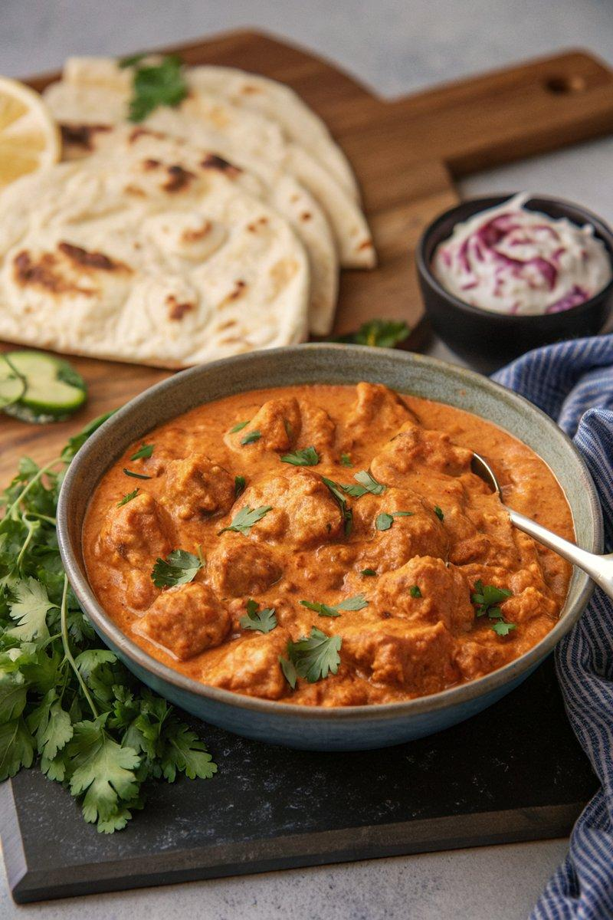

INGREDIENTS  - {'group': 'Main', 'item': '600g chicken breasts, chopped into bite-size chunks'}  - {'group': 'Marinade', 'item': '120ml Greek yogurt, 2 garlic cloves minced, 1 tbsp minced ginger, juice of 1 lemon, 1 tsp ground coriander, 1/2 tsp turmeric, 1/2 tsp ground cumin, 1 tsp paprika, 1/2 tsp mild chilli powder, a pinch of cinnamon, 1/2 tsp salt, 1/2 tsp ground black pepper'}  - {'group': 'Sauce', 'item': '1 tbsp sunflower oil, 1 tbsp unsalted butter, 1 onion finely chopped, 3 garlic cloves minced, 2 tsp minced ginger, 1 tsp garam masala, 2 tsp ground coriander, 2 tsp paprika, 1 tsp ground cumin, 1/2 tsp cinnamon, 1 red bell pepper finely chopped, 2 tbsp tomato purée, 400g can chopped tomatoes, 180ml double cream, 3 tbsp ground almonds, 1 tbsp brown sugar'} | PREP  Combine chicken pieces with Greek yogurt, garlic, ginger, lemon juice, coriander, turmeric, cumin, paprika, chilli powder, cinnamon, salt, and pepper in a bowl. Mix well, cover, and refrigerate for 2-3 hours to marinate.  COOK  Heat sunflower oil and butter in a large frying pan over medium-high heat. Sauté onion for 4-5 mins until softened. Add garlic, ginger, garam masala, coriander, paprika, cumin, cinnamon, and tomato purée. Cook for 2-3 mins until fragrant. Stir in bell pepper, chopped tomatoes, and 120ml water. Bring to a boil, then simmer for 15-20 mins until thickened. Meanwhile, preheat grill and arrange marinated chicken on a baking sheet. Brush with oil and grill for 8-10 mins until charred and cooked through. Stir cream, ground almonds, and brown sugar into the sauce, then add grilled chicken. Simmer for 5 mins to heat through.  PLATING  Serve the chicken tikka masala hot with cooked rice or flatbreads. Garnish with fresh coriander and red onion slices if desired.

NOTES:
Extra chicken tikka can be used in salads or wraps. The dish can be made ahead and stored in the fridge for up to 2 days. Reheat thoroughly before serving.

