CREAMY BUTTER CHICKEN CURRY  COOK TIME: 20 mins  SOURCE: Unknown  #chicken #Indian #sauté | 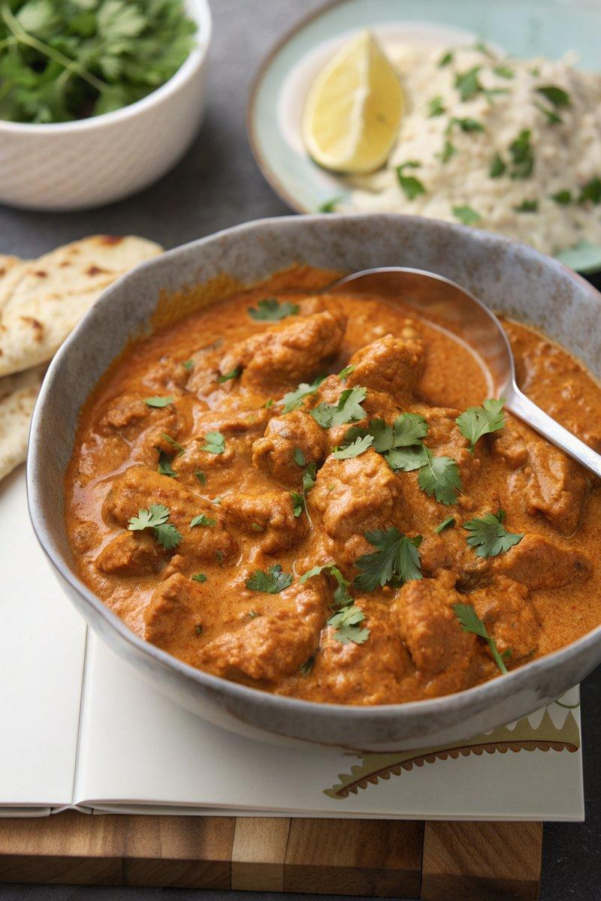

INGREDIENTS  - {'group': 'Chicken & Marinade', 'item': '4 chicken breasts, diced'}  - {'group': 'Chicken & Marinade', 'item': '80ml natural yogurt'}  - {'group': 'Chicken & Marinade', 'item': '1 tbsp lemon juice'}  - {'group': 'Chicken & Marinade', 'item': '1 garlic clove, minced'}  - {'group': 'Chicken & Marinade', 'item': '1 tsp garam masala'}  - {'group': 'Chicken & Marinade', 'item': '1 tsp ground coriander'}  - {'group': 'Chicken & Marinade', 'item': '1 tsp paprika'}  - {'group': 'Chicken & Marinade', 'item': '1 tsp mild chilli powder'}  - {'group': 'Sauce', 'item': '1 onion, chopped'}  - {'group': 'Sauce', 'item': '4 garlic cloves, peeled'}  - {'group': 'Sauce', 'item': '2 tsp minced ginger'}  - {'group': 'Sauce', 'item': '3 tbsp butter'}  - {'group': 'Sauce', 'item': '1 tbsp sunflower oil'}  - {'group': 'Sauce', 'item': '1/4 tsp salt'}  - {'group': 'Sauce', 'item': '1 1/2 tbsp garam masala'}  - {'group': 'Sauce', 'item': '1 tbsp curry powder'}  - {'group': 'Sauce', 'item': '1 tsp paprika'}  - {'group': 'Sauce', 'item': '1/2 tsp cinnamon'}  - {'group': 'Sauce', 'item': '120ml chicken stock'}  - {'group': 'Sauce', 'item': '400g passata'}  - {'group': 'Sauce', 'item': '2 tbsp tomato purée'}  - {'group': 'Sauce', 'item': '2 tsp sugar'}  - {'group': 'Sauce', 'item': '6 cardamom pods'}  - {'group': 'Sauce', 'item': '175ml double cream'}  - {'group': 'Garnish', 'item': 'Fresh coriander'} | PREP  Combine diced chicken with yogurt, lemon juice, minced garlic, garam masala, ground coriander, paprika, and mild chilli powder in a bowl. Mix well, cover, and refrigerate for at least 1 hour.  COOK  Blend onion, garlic, and ginger in a food processor until smooth. Heat butter and sunflower oil in a large pan over medium-high heat. Add the onion mixture and cook for 5-6 mins until the onion browns. Add marinated chicken and cook for 3-4 mins until sealed. Stir in salt, garam masala, curry powder, paprika, and cinnamon, cooking for 1-2 mins until fragrant. Pour in chicken stock, passata, tomato purée, sugar, and cardamom pods. Bring to a boil, then simmer for 15 mins. Remove cardamom pods, stir in cream, and heat through.  PLATING  Serve the butter chicken hot, garnished with fresh coriander. Accompany with rice or naan for a complete meal.

NOTES:
For a grilled version, broil the marinated chicken before adding it to the sauce. The curry can be made ahead and stored in the refrigerator for up to 2 days.

