SLOW-COOKED BEEF MADRAS CURRY  COOK TIME: 3 hrs 20 mins  SOURCE: Unknown  #beef #Indian #slow-cook | 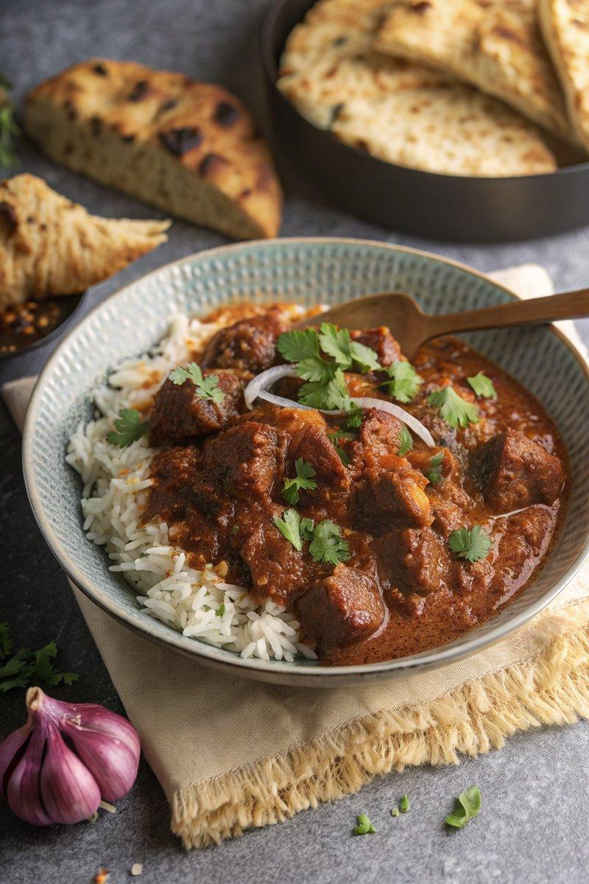

INGREDIENTS  - {'group': 'Main', 'item': '500g braising beef, cut into bite-size chunks'}  - {'group': 'Main', 'item': '1 large onion, roughly chopped'}  - {'group': 'Main', 'item': '3 garlic cloves, peeled'}  - {'group': 'Main', 'item': '1 thumb-size piece of ginger, roughly chopped'}  - {'group': 'Main', 'item': '3 tbsp sunflower oil or ghee'}  - {'group': 'Main', 'item': '2 bay leaves'}  - {'group': 'Sauce', 'item': '2 tbsp tomato purée'}  - {'group': 'Sauce', 'item': '½ tsp ground cinnamon'}  - {'group': 'Sauce', 'item': '3 tbsp hot Madras curry powder'}  - {'group': 'Sauce', 'item': '¼ tsp ground fenugreek'}  - {'group': 'Sauce', 'item': '½ tsp tamarind paste'}  - {'group': 'Seasoning', 'item': '½ tsp salt'}  - {'group': 'Seasoning', 'item': '½ tsp ground black pepper'}  - {'group': 'Sauce', 'item': '480ml beef stock'}  - {'group': 'Sauce', 'item': '420g passata'}  - {'group': 'For Serving', 'item': 'cooked basmati rice'}  - {'group': 'For Serving', 'item': 'naan'}  - {'group': 'Garnish', 'item': 'fresh coriander, roughly chopped'}  - {'group': 'Garnish', 'item': 'finely sliced red onion'} | PREP  Preheat the oven to 160°C (320°F (160°C)). Blend the onion, garlic, and ginger in a food processor until smooth.  COOK  Heat 2 tbsp of oil in a large casserole pan over medium-high heat. Brown the beef chunks for 7-8 mins, then set aside. Add the remaining oil to the pan and sauté the onion paste with bay leaves for 5-6 mins until slightly browned. Stir in tomato purée, cinnamon, curry powder, fenugreek, tamarind paste, salt, and pepper, cooking for 2-3 mins until fragrant. Pour in beef stock and passata, bring to a boil, then return the beef and juices to the pan. Cover and bake in the oven for 3 hrs, checking occasionally and adding water if needed.  PLATING  Serve the beef Madras with basmati rice and naan. Garnish with fresh coriander and red onion slices.

NOTES:
For added vegetables, consider mushrooms or bell peppers before baking. This dish can be made ahead and refrigerated for up to 2 days. Reheat thoroughly before serving.

