TRADITIONAL LAMB LANCASHIRE HOTPOT  COOK TIME: 2 hrs  SOURCE: Unknown  #lamb #British #bake | 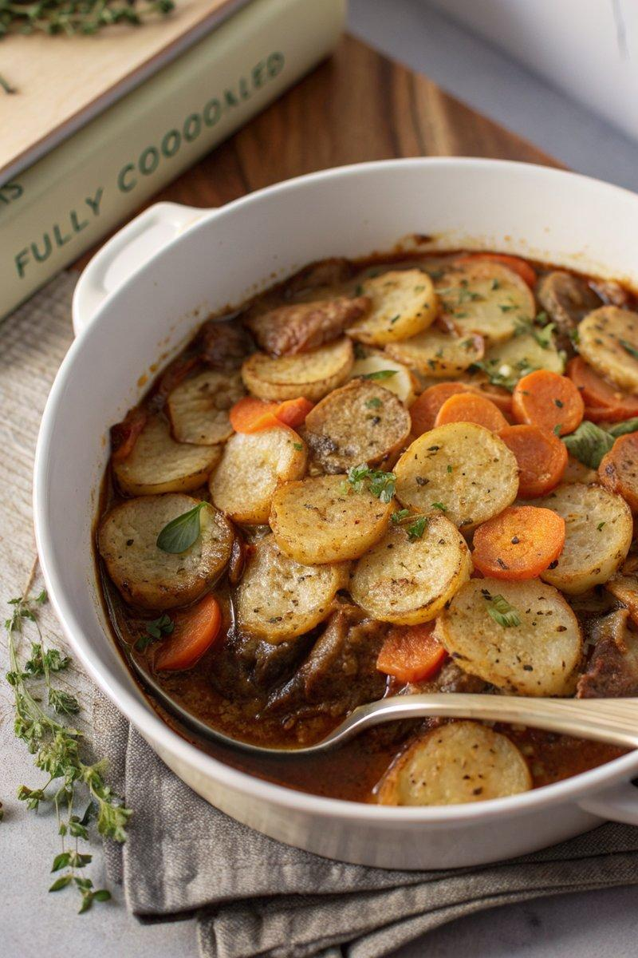

INGREDIENTS  - {'group': 'Main', 'item': '500g lamb neck or shoulder, cut into bite-size chunks'}  - {'group': 'Main', 'item': '2 onions, peeled and thinly sliced'}  - {'group': 'Main', 'item': '3 medium carrots, peeled and cut into chunks'}  - {'group': 'Main', 'item': '680g floury potatoes, peeled and thinly sliced'}  - {'group': 'Sauce', 'item': '480ml hot chicken or lamb stock'}  - {'group': 'Sauce', 'item': '1 tbsp Worcestershire sauce'}  - {'group': 'Seasoning', 'item': '1 heaped tbsp plain flour'}  - {'group': 'Seasoning', 'item': '2 bay leaves'}  - {'group': 'Seasoning', 'item': '½ tsp salt'}  - {'group': 'Seasoning', 'item': '½ tsp ground black pepper'}  - {'group': 'Seasoning', 'item': '¼ tsp dried thyme'}  - {'group': 'For Cooking', 'item': '1 tbsp unsalted butter'}  - {'group': 'For Cooking', 'item': '1 tbsp sunflower oil'}  - {'group': 'For Brushing', 'item': '1 tbsp melted unsalted butter'} | PREP  Preheat the oven to 170°C (340°F (171°C)). Peel and slice the onions and potatoes. Cut the lamb into bite-size chunks and the carrots into pieces.  COOK  In a casserole dish, melt butter with sunflower oil over medium heat. Sauté the lamb until browned, about 3-4 mins. Remove lamb and cook onions until soft, about 3-4 mins. Return lamb to the dish, sprinkle with flour, and stir for 1 min. Add stock, bay leaves, salt, pepper, and Worcestershire sauce. Bring to a boil, cover, and bake for 30 mins. Stir in carrots, layer potatoes on top, brush with melted butter, sprinkle thyme, cover, and bake for 1 hr. Increase oven to 200°C (400°F (200°C)), uncover, and bake for another 30 mins until potatoes are crisp.  PLATING  Let the hotpot rest for 5 mins before serving. Serve hot, garnished with fresh thyme if desired.

NOTES:
For best flavour, use lamb with some fat. Adjust seasoning to taste before serving.

