LAMB SHEPHERD'S PIE WITH CREAMY MASH  COOK TIME: 35 mins  SOURCE: Unknown  #lamb #British #baked | 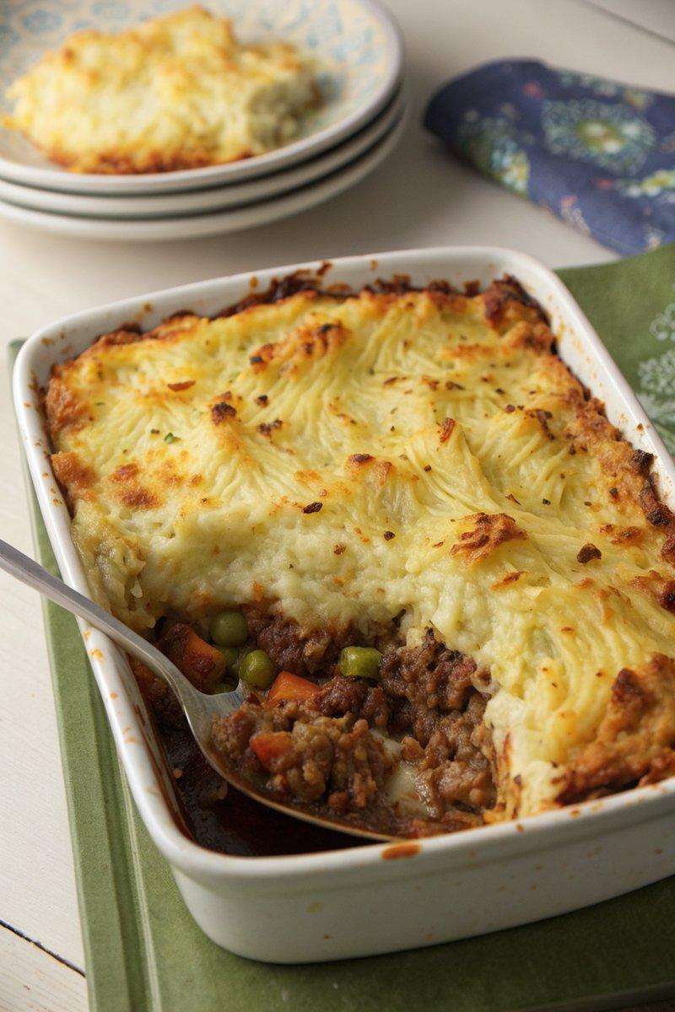

INGREDIENTS  - {'group': 'Main', 'item': '1.8kg floury potatoes, peeled and chopped'}  - {'group': 'Main', 'item': '2 tbsp sunflower oil'}  - {'group': 'Main', 'item': '2 onions, finely chopped'}  - {'group': 'Main', 'item': '2 celery sticks, finely chopped'}  - {'group': 'Main', 'item': '2 carrots, finely chopped'}  - {'group': 'Main', 'item': '900g minced lamb'}  - {'group': 'Seasoning', 'item': '1 tsp salt'}  - {'group': 'Seasoning', 'item': '1 tsp ground black pepper'}  - {'group': 'Sauce', 'item': '2 tbsp Worcestershire sauce'}  - {'group': 'Sauce', 'item': '1L beef or lamb stock'}  - {'group': 'Mash', 'item': '120ml double cream'}  - {'group': 'Mash', 'item': '120g unsalted butter'}  - {'group': 'Thickener', 'item': '2 tbsp cornflour mixed with 4 tbsp cold water'} | PREP  Peel and chop the potatoes into large chunks. Finely chop the onions, celery, and carrots. Prepare the cornflour slurry by mixing cornflour with cold water.  COOK  Boil the potatoes in a large pot of water for 15 mins until tender. Meanwhile, preheat the oven to 200°C (400°F (200°C)). In a large skillet, heat sunflower oil over medium heat. Sauté onions, celery, and carrots for 5 mins until softened. Add minced lamb, cooking until browned. Season with half the salt and pepper, then stir in Worcestershire sauce and stock. Simmer for 5 mins. Drain and mash the potatoes with cream, butter, and remaining salt and pepper. Stir the cornflour slurry into the lamb mixture to thicken.  PLATING  Transfer the lamb mixture to a baking dish, leaving most of the gravy behind. Spread the mashed potatoes over the top, roughing up the surface with a fork. Bake for 20 mins until the top is golden brown. Serve with reheated gravy and sides of savoy cabbage and pickled red cabbage.

NOTES:
To make ahead, prepare up to the baking step, cool, and refrigerate for up to 2 days. Bake directly from the fridge, adding 5-10 mins to the baking time.

