CHICKEN STEW WITH CHEDDAR DUMPLINGS  COOK TIME: 50 mins  SOURCE: Unknown  #chicken #American #bake | 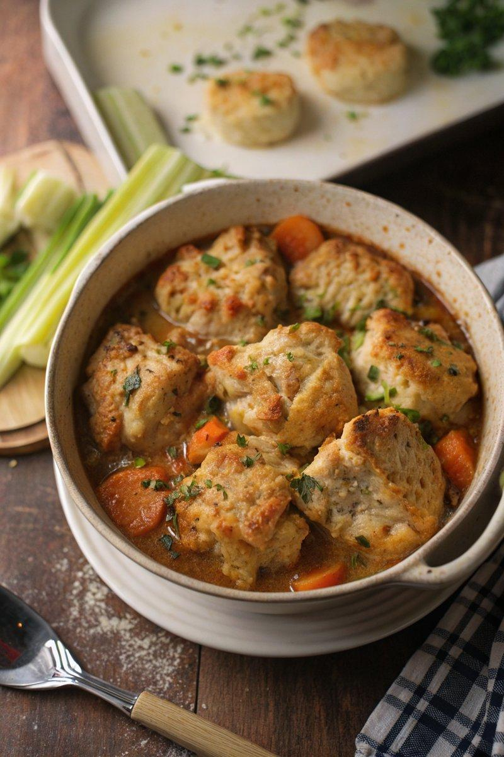

INGREDIENTS  - {'group': 'Main', 'item': '720g skinless chicken thigh fillets, quartered'}  - {'group': 'Main', 'item': '3 carrots, peeled and chopped'}  - {'group': 'Main', 'item': '3 medium potatoes, peeled and chopped'}  - {'group': 'Main', 'item': '2 celery sticks, sliced'}  - {'group': 'Main', 'item': '1.2L chicken stock'}  - {'group': 'Main', 'item': '½ tsp salt'}  - {'group': 'Main', 'item': '½ tsp ground black pepper'}  - {'group': 'Main', 'item': '1 tsp dried thyme'}  - {'group': 'Main', 'item': '3 tbsp unsalted butter'}  - {'group': 'Main', 'item': '1 large onion, diced'}  - {'group': 'Main', 'item': '50g plain flour'}  - {'group': 'Dumplings', 'item': '240g plain flour'}  - {'group': 'Dumplings', 'item': '3 tsp baking powder'}  - {'group': 'Dumplings', 'item': '100g grated mature Cheddar'}  - {'group': 'Dumplings', 'item': '½ tsp dried parsley'}  - {'group': 'Dumplings', 'item': '2 tbsp unsalted butter, melted'}  - {'group': 'Dumplings', 'item': '180ml milk'}  - {'group': 'Garnish', 'item': 'Chopped flat-leaf parsley'} | PREP  Quarter the chicken thighs and chop the carrots, potatoes, and celery. Dice the onion and grate the Cheddar cheese.  COOK  In a large saucepan, combine chicken, carrots, potatoes, celery, salt, pepper, thyme, and chicken stock. Bring to a boil, then simmer for 15 mins. Preheat the oven to 190°C (375°F (190°C)). In a casserole dish, melt butter over medium heat, add onion, and cook until softened. Stir in flour to form a roux, then gradually whisk in the stock from the saucepan until thickened. Add the chicken and vegetables to the sauce and simmer.  PLATING  Spoon the dumpling mixture over the stew, bake for 15-20 mins until dumplings are golden. Rest for 5 mins, garnish with parsley, and serve.

NOTES:
For a twist, substitute Cheddar with Red Leicester or Parmesan. Add garlic powder for extra flavour.

