SLOW-COOKED SCOTTISH BEEF STEW  COOK TIME: 4 hrs  SOURCE: Unknown  #beef #Scottish #slow-cook | 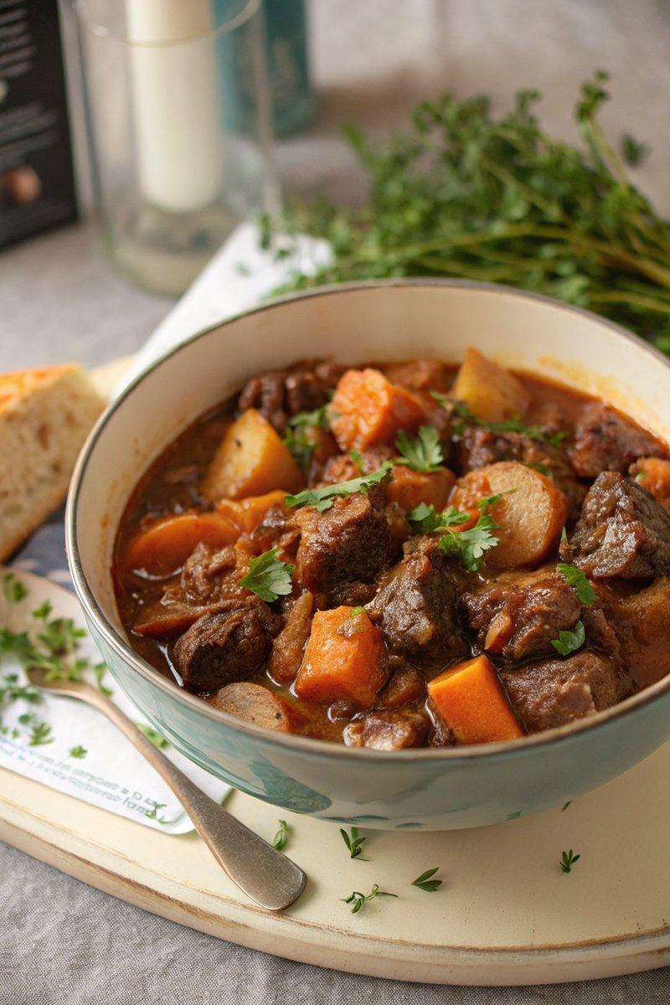

INGREDIENTS  - {'group': 'Main', 'item': '1kg braising beef, chopped into bite-size chunks'}  - {'group': 'Main', 'item': '2 tbsp sunflower oil'}  - {'group': 'Main', 'item': '2 large onions, chopped'}  - {'group': 'Main', 'item': '3 garlic cloves, minced'}  - {'group': 'Main', 'item': '2 large carrots, chopped'}  - {'group': 'Main', 'item': '2 medium potatoes, chopped'}  - {'group': 'Main', 'item': '1/2 small swede, chopped'}  - {'group': 'Sauce', 'item': '500ml red wine'}  - {'group': 'Sauce', 'item': '720ml beef stock'}  - {'group': 'Sauce', 'item': '2 tbsp tomato purée'}  - {'group': 'Sauce', 'item': '1 tbsp Worcestershire sauce'}  - {'group': 'Seasoning', 'item': '2 tbsp red currant jelly or cranberry sauce'}  - {'group': 'Seasoning', 'item': '4 bay leaves'}  - {'group': 'Seasoning', 'item': '2 tsp dark brown sugar'}  - {'group': 'Seasoning', 'item': '1/2 tsp salt'}  - {'group': 'Seasoning', 'item': '1/4 tsp ground black pepper'}  - {'group': 'Garnish', 'item': 'thyme sprigs'} | PREP  Preheat the oven to 165°C (329°F (165°C)). Mix the flour with a pinch of salt and pepper, then coat the beef chunks in this mixture. Chop the onions, garlic, carrots, potatoes, and swede.  COOK  Heat sunflower oil in a large pan over medium heat. Brown the floured beef chunks for 7-8 mins until golden. Add onions and cook for another 5 mins. Stir in garlic, red currant jelly, and red wine, simmering for 5 mins. Add carrots, potatoes, swede, beef stock, tomato purée, Worcestershire sauce, bay leaves, sugar, salt, and pepper. Bring to a gentle boil, cover, and transfer to the oven. Cook for 3-4 hrs, stirring occasionally.  PLATING  Serve the stew hot, garnished with fresh thyme sprigs and accompanied by chunks of fresh bread.

NOTES:
This stew can be made ahead and refrigerated for up to 2 days. Reheat on the stovetop until piping hot.

