CHEESE AND ONION PIES  COOK TIME: 35 mins  SOURCE: Unknown  #vegetarian #British #bake | 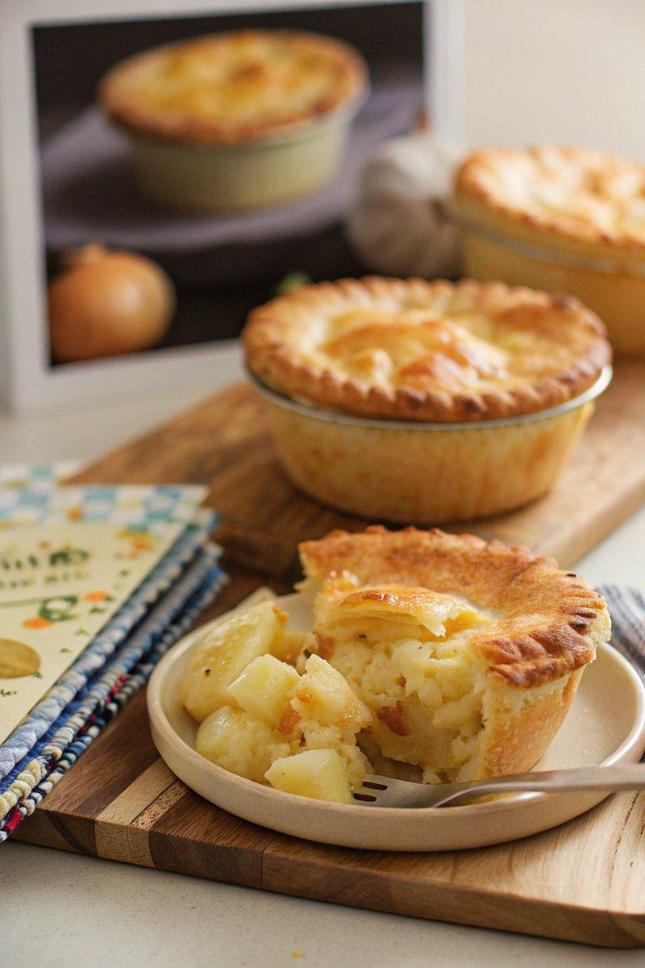

INGREDIENTS  - {'group': 'Main', 'item': '2 x 320g packs ready-rolled shortcrust pastry'}  - {'group': 'Main', 'item': '1 medium potato, peeled and diced into 1cm cubes'}  - {'group': 'Main', 'item': '1 large onion, finely sliced'}  - {'group': 'Main', 'item': '150g mature Cheddar, grated'}  - {'group': 'Main', 'item': '1 egg, lightly whisked'}  - {'group': 'Sauce', 'item': '2 tbsp unsalted butter'}  - {'group': 'Sauce', 'item': '2 tbsp plain flour'}  - {'group': 'Sauce', 'item': '180ml milk'}  - {'group': 'Sauce', 'item': '50ml double cream'}  - {'group': 'Seasoning', 'item': '1/2 tsp ground black pepper'}  - {'group': 'Seasoning', 'item': '1/4 tsp salt'}  - {'group': 'Seasoning', 'item': '1/2 tsp mustard powder'} | PREP  Preheat the oven to 200°C (400°F (200°C)). Unroll one pastry sheet and cut into four squares. Line four 10cm (4-inch) pie dishes with the pastry, ensuring it covers the base and sides with a slight overhang. Prick the base with a fork, cover with parchment, and fill with baking beans.  COOK  Bake the pastry cases for 10 mins, then cool for 10 mins. Meanwhile, boil the diced potato for 10-12 mins until tender, then drain. In a saucepan, melt butter and sauté the onion for 5 mins until soft. Stir in flour, then gradually add milk, stirring until smooth. Mix in cream, cheese, mustard powder, salt, and pepper, then fold in the potato. Cook until the cheese melts and the mixture thickens.  PLATING  Divide the filling among the pie cases. Trim the pastry edges, brush with egg wash, and cover with squares from the second pastry sheet. Trim excess, crimp edges, brush tops with egg wash, and pierce holes. Bake for 20-25 mins until golden brown.

NOTES:
Ensure the filling is thick but pourable; add a splash of milk if needed. Serve warm with a side of green salad or mashed peas.

